
  - MANSOURA UNIVERSITY
  - FACULTY OF ENGINEERING
  - MECHATRONICS ENGINEERING PROGRAM



Automated “Follow-Me” Cart Using AI and Computer Vision for Disabled and Elderly Assistance
Project Members ID number
Hussain Ahmed Ibrahim Abd Al-Aziz Rizk 803084842
Eyad Medhat Mohamed Abdeljawad 803089397
Mohamed Ahmed Fouad Ahmed Mansy 805771560
Kareem Abdelaziz Ibrahim Abdallah 803089481
Ahmad Mohammad Abdulmajid Yunus 803085462
Mohamed Shawky Shawky Soliman 803089402
Faris El-Sayed Nabeeh Elasaly 806096665
Mohamed Ahmed Ramadan Abd Al-Atty 803084384
Mohamed Ibrahim Abd El-Mawla 803089386
Abd Al-Rahman Mahmoud El-Saeed Mohamed 803084739
Supervisors:
Prof. Sabry Saraya
Eng. Ali El-Henidy
Academic Year: Fall 2024-2025

ACKNOWLEDGMENT

We would like to express our deepest gratitude to Dr. Sabry Saraya for his continuous guidance and mentorship throughout the project.

We also thank Eng. Ali El-Henidy for being the consultant and advisor we needed. The recommendations we received were of utmost value and dramatically improved the quality of our project.

Special thanks to Eng. Ahmed Ibrahim and Eng. Mariam Helal and

Eng. Khaled Waleed for volunteering their time and effort to assist us with their experience and exceptional quality. We cannot forget our friends and colleagues who provided us with their prior experiences; we thank every single one of you.

Last but not least, we are profoundly grateful to our families. Their constant encouragement and support during our study years in this faculty have been the driving force behind every success we achieve. For that, we are truly thankful.

ABSTRACT
The "Automated Follow-Me Cart Using AI and Computer Vision for Disabled and Elderly Assistance" addresses the growing need for accessible and intelligent mobility solutions in an aging society and for individuals with physical disabilities. This project integrates advanced computer vision and artificial intelligence to develop a smart cart capable of autonomously following its user based on intuitive hand gesture recognition. By leveraging deep learning algorithms, the system processes real-time video streams to identify user gestures, ensuring accurate and responsive tracking.
In addition to following the user, the cart incorporates state-of-the-art sensors for obstacle detection and avoidance, promoting safety in crowded or confined spaces. These sensors enable the cart to identify and navigate around obstacles such as people, furniture, or shelves while maintaining a consistent distance from the user. Furthermore, proximity and tracking sensors enhance the cart's ability to adapt to dynamic environments, ensuring reliable operation in diverse settings like homes, hospitals, and supermarkets.
The mechanical design emphasizes durability, portability, and efficiency. It is engineered with robust materials and optimized for lightweight construction, allowing easy maneuverability across various terrains. The integrated motors and power system ensure smooth and energy-efficient operation, while the modular design facilitates maintenance and scalability.
This project represents a multidisciplinary effort that combines mechanical engineering, computer vision, sensor integration, and artificial intelligence to create a user-friendly and accessible solution. By improving the independence and quality of life of disabled and elderly individuals, the Automated Follow-Me Cart contributes to a more inclusive society and demonstrates the transformative potential of modern engineering and technology.

TABLE OF CONTENTS
1. Introduction 15
1.1 Background and Motivation 16
1.2 Overview of the Project 16
1.3 Scope and Objectives 18
1.4 Significance of the Project 18
1.5 Methodology Overview 19
1.6 Objectives 20
2. Literature Review 22
2.1 Mobility Aids and Assistive Technologies 22
2.2 Autonomous Mobile Robots (AMRs) 23
2.3 Hand Gesture Recognition 23
2.4 Obstacle Detection and Avoidance 24
2.5 AI and Machine Learning in Robotics 25
2.6 Integration of Hardware and Software 26
2.7 Conclusion 26
3. Mechanical Design 28
3.1 The Design 29
3.1.1 Material Selection for the Prototype 30
3.1.2 Designing the dimensions 32
3.2 Mechanical components 33
3.2.1 Back Part 34
3.2.2 Right Side 34
3.2.3 Upper Part Base 35
3.2.4 Lower Part Base 36
3.2.5 Support Links 37
3.2.6 The Motor 37
3.2.7 Methodology of searching 38
3.2.8 The Component Box Cover 40
3.2.9 The Component Box 41
3.2.10 The Handle 43
3.2.11 Wheels and couplers 44
3.3 The Difficulties We Faced 47
3.3.1 Mounting the Motor 47
3.3.2 Wiring 48
4. Hardware Implementation 51
4.1 Introduction 51
4.2 Detailed Analysis of Hardware Components 51
4.2.1 Motors 51
4.2.2 Motor Drivers 52
4.2.3 Sensors 55
4.2.4 Camera 57
4.2.5 Microcontroller (Arduino Nano) 58
4.2.6 NVIDIA Jetson Platform 59
4.2.7 Battery 60
4.2.8 Mechanical Components 61
4.3 Integration and Implementation 61
4.3.1 Wiring and Assembly 61
4.3.2 PCB Design and Layout 62
4.3.3 Challenges and Solutions 67
4.3.4 Testing and Validation 69
4.4 Hardware Optimization 73
4.4.1 Energy Efficiency 73
4.4.2 Durability Enhancements 74
4.4.3 Thermal Management 75
4.4.4 Maintenance Considerations 75
4.5 Challenges and Lessons Learned 76
4.5.1 Key Difficulties 76
4.5.2 Lessons Learned 77
5. Software Integration 81
5.1 Software and System Integration Introduction 81
5.2 Why Smart Shopping Cart 81
5.3 System Overview 82
5.4 Software Background 85
5.4.1 Artificial Intelligence (AI) 85
5.4.2 Machine Learning (ML) 85
5.4.3 Deep Learning (DL) 85
5.4.4 Computer Vision 86
5.4.5 Convolutional Neural Networks (CNNs) 86
5.5 YOLO 87
5.5.1 Introduction to YOLO 87
5.5.2 Key Features of YOLO 87
5.5.3 How YOLO Works 88
5.5.4 Using YOLO in the Smart Shopping Cart Project 89
5.6 Mediapipe 92
5.6.1 Mediapipe Application in the Project 92
5.6.2 How We Used Mediapipe in the Project 95
5.7 Computer Vision usage in the project 99
5.7.1 Developing an Accurate Hand Gesture System and Clothing Detection with YOLO 99
5.7.2 Clothing Detection with YOLO Development Process 100
5.7.3 System Integration Process 101
5.7.4 Testing and Refinement 102
5.8 Setting up HW (Jetson nano) 102
5.8.1 Initializing the Jetson Nano 102
5.9 ATmega328P 106
5.9.1 ATmega328P Project Design 106
5.9.2 MCAL Layer 106
5.9.3 HAL Layer 107
5.9.4 Application Layer 107
5.10 UI Design and Implementation 108
5.10.1 Introduction to the App 108
5.10.2 Key Features of the App 109
5.10.3 UI Design Principles 114
5.10.4 Technical Implementation 114
5.10.5 Conclusion 114
6. Project Management and Cost 116
6.1 Project Management Procedure 116
6.1.1 Idea Development 116
6.1.2 Resource Identification 116
6.1.3 Timeline Estimation 117
6.1.4 Team Organization 119
6.1.5 Risk Management 119
6.2 Cost 120
6.2.1 Mechanical Costs 120
6.2.2 Hardware Costs 121
6.2.3 Software Costs 122
6.2.4 Total Cost 122
7. Development and Recommendations 124
7.1 Introduction 124
7.2 Problems and Solutions 124
7.2.1 Mechanical Problems 124
7.2.2 Hardware Problems 125
7.2.3 Software Problems 126
7.3 Future Work 127
7.3.1 Mechanical Enhancements 127
7.3.2 Hardware Upgrades 127
7.3.3 Software Improvements 128
7.4 Recommendations 128
References 129

LIST OF FIGURES
Figure 1.1: Fields that Mechatronics Cover .......................................................................... 16
Figure 3.1: CAD Perspective ................................................................................................ 28
Figure 3.2: Real-View Perspective ........................................................................................ 28
Figure 3.3: Complete Design on SOLIDWORKS ................................................................ 30
Figure 3.4: Lower Part (Bottom View) ................................................................................. 31
Figure 3.5: Lower Part (Top View) ....................................................................................... 31
Figure 3.6: Upper Part of the Cart ......................................................................................... 31
Figure 3.7: The Linking Part ................................................................................................. 32
Figure 3.8: Side View of the Cart .......................................................................................... 32
Figure 3.9: Dimensions of the Cart ....................................................................................... 33
Figure 3.10: Components Used in the Design ....................................................................... 34
Figure 3.11: Back Side of the Upper Part .............................................................................. 35
Figure 3.12: Right Side of the Upper Part ............................................................................. 35
Figure 3.13: Left Side of the Upper Part ............................................................................... 35
Figure 3.14: Base of the Upper Part ...................................................................................... 36
Figure 3.15: Lower Part of the Cart ...................................................................................... 36
Figure 3.16: Connecting Links .............................................................................................. 37
Figure 3.17: Threaded Rods .................................................................................................. 37
Figure 3.18: The Wiper Motor .............................................................................................. 37
Figure 3.19: The Used Motor ................................................................................................ 40
Figure 3.20: Opening of the Component Box ....................................................................... 41
Figure 3.21: Closing of the Component Box ........................................................................ 41
Figure 3.22: The Handle of the Cart ..................................................................................... 43
Figure 3.23: The Wheel and the Coupler .............................................................................. 44
Figure 3.24: Other Side of the Wheel .................................................................................... 44
Figure 3.25: Dimensions of the Motor .................................................................................. 48
Figure 3.26: Wiring of the Lower Part .................................................................................. 49
Figure 4.1: Motor Driver Layout ........................................................................................... 60
Figure 4.2: 3D Model for Motor Driver ................................................................................ 61
Figure 4.3: Schematic View of Motor Driver ........................................................................ 61
Figure 4.4: IR Sensor Layout ................................................................................................ 57
Figure 4.5: Ultrasonic Sensor Layout ................................................................................... 57
Figure 4.6: Camera Used with Jetson Nano .......................................................................... 58
Figure 4.7: Arduino Nano ..................................................................................................... 59
Figure 4.8: Jetson Nano ......................................................................................................... 60
Figure 4.9: Royal Battery 12N9-BS ...................................................................................... 61
Figure 4.10: Jumpers and Wires ............................................................................................ 62
Figure 4.11: Safety PCB Layout ........................................................................................... 63
Figure 4.12: 3D Model for Safety PCB ................................................................................. 64
Figure 4.13: Schematic View for Safety PCB ....................................................................... 65
Figure 4.14: Joystick PCB Layout ........................................................................................ 66
Figure 4.15: 3d Model for Joystick PCB ............................................................................... 69
Figure 4.16: Schematic View for Joystick PCB .................................................................... 69
Figure 5.1: Jetson Nano Interface ......................................................................................... 81
Figure 5.2: ATmega328P ....................................................................................................... 83
Figure 5.3: Camera used with Jetson Nano ........................................................................... 83
Figure 5.4: IR Sensor Both Ways .......................................................................................... 84
Figure 5.5: YOLO V8 Logo .................................................................................................. 87
Figure 5.6: Object detection and classification ex1 .............................................................. 88
Figure 5.7: Object detection and classification ex2 .............................................................. 88
Figure 5.8: Mediapipe logo ................................................................................................... 92
Figure 5.9: Hand landmark points ......................................................................................... 93
Figure 5.10: Follow Me Signaling from Hand Gestures ....................................................... 95
Figure 5.11: Stop Signaling from Hand Gestures ................................................................. 95
Figure 5.12: Jetson Interface ............................................................................................... 103
Figure 5.13: Application Interface ...................................................................................... 109
Figure 5.14: Welcome Page ………..................................................................................... 109
Figure 5.15: Register and Log-in Page ……….................................................................... 110
Figure 5.16: Recognition Page ………................................................................................ 110
Figure 5.17: Store Mapping Page ………............................................................................ 111
Figure 5.18: Cart Control Page ………................................................................................ 112
Figure 5.19: Battery Monitoring Page ………..................................................................... 112
Figure 5.20: Cart Content Page ………............................................................................... 113

LIST OF TABLES
Table 6.1: Timeline Schedule ............................................................................................... 111
Table 6.1: Mechanical Costs ................................................................................................ 113
Table 6.2: Hardware Costs ................................................................................................... 114
Table 6.3: Software Costs .................................................................................................... 115
Table 6.4: Total Costs .......................................................................................................... 115
Table 7.1: Recommendations .............................................................................................. 121

LIST OF ABBREVIATIONS
AI Artificial Intelligence
PCB Printed Circuit Board
AC Alternative Current
DC Direct Current
CAD Computer-Aided Design
IR Infrared
LIDAR Light Detection and Ranging
UART Universal asynchronous receiver / transmitter
BMS Battery Management System
GPU Graphics processing unit

Chapter 1 Introduction

Introduction
Mobility challenges faced by elderly individuals and those with physical disabilities can significantly impact their independence and overall quality of life. Activities that many take for granted, such as carrying groceries, moving objects, or navigating crowded spaces, can be overwhelming without proper assistance. Recognizing these challenges, our graduation project focuses on creating an intelligent solution—the Automated Follow-Me Cart Using AI and Computer Vision for Disabled and Elderly Assistance. This innovative cart is designed to enhance mobility, safety, and convenience for users, leveraging modern technologies to address a growing societal need.
The project was developed within the Mechatronics Engineering Department, a multidisciplinary field that integrates mechanics, electronics, computer science, and control engineering to design and create intelligent systems. The department fosters innovation by encouraging students to apply their knowledge to solve real-world problems, such as those tackled in this project. As shown in Figure 1.1, the Mechatronics Department emphasizes the intersection of these core engineering disciplines, making it an ideal environment for developing complex systems like the Automated Follow-Me Cart.
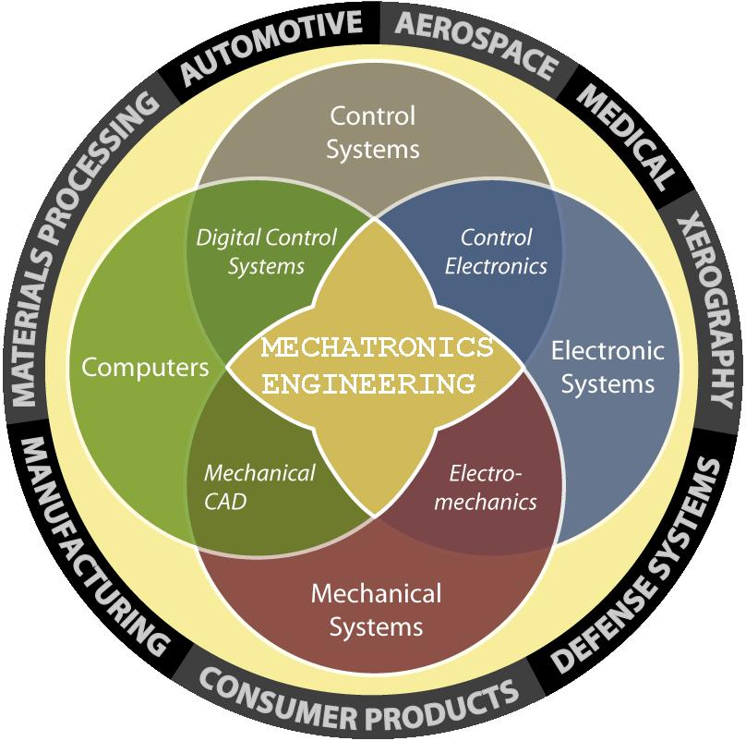
In this section, we will introduce the project’s goals, its key components, and the methodologies used in its design and implementation. We aim to provide a comprehensive overview of how the cart integrates advanced technologies to address practical challenges in assistive mobility.
Figure 1.1 Feilds that Mechatronics cover

1.1 Background and Motivation
The increasing global aging population and the prevalence of physical disabilities underscore the need for assistive technologies. According to recent studies, mobility aids such as wheelchairs and walkers have limitations in providing seamless, independent mobility. These devices often require significant human effort or assistance from caregivers. This creates a demand for smarter, more autonomous systems that can adapt to the user’s needs and environment.
Our project addresses these issues by combining artificial intelligence, computer vision, and mechanical design. The cart is specifically designed to follow the user autonomously, carry loads, and avoid obstacles in real-time. This blend of technologies ensures that users can move independently with minimal effort, promoting inclusivity and improving their quality of life.

1.2 Overview of the Project
The Automated Follow-Me Cart integrates multiple disciplines, including mechanical engineering, electronics, artificial intelligence, and computer vision. The primary objective is to create a cart that can follow a user intuitively, avoiding obstacles and ensuring smooth operation across different terrains.
The project’s mechanical structure was designed using SolidWorks, a powerful 3D CAD software widely used for engineering design and simulation. SolidWorks allowed the team to create a lightweight yet robust cart body that ensures durability and reliability. The design was optimized for weight distribution, easy maneuverability, and integration of electronic components such as sensors, motors, and processing units.

Key hardware components of the cart include:
- Four Motors: These provide stable and smooth movement, allowing the cart to traverse various surfaces with ease.
- Two Motor Drivers: Essential for precise control of the motors, ensuring the cart responds accurately to commands.
- Three Infrared (IR) Sensors: These sensors detect nearby obstacles and ensure real-time obstacle avoidance.
- A Camera: Used for real-time hand gesture recognition, the camera enables the cart to interpret and respond to user commands effectively.
- NVIDIA Jetson Platform: Serving as the AI computation unit, this platform processes the camera’s input for gesture recognition and controls the cart’s movement.
- Arduino Nano: A versatile microcontroller that handles auxiliary functions and integrates seamlessly with the other components.
- A Rechargeable Battery: Ensures the cart operates independently without the need for external power, providing portability and convenience.

1.3 Scope and Objectives
The project aims to address the following key objectives:
- Mobility Assistance: Provide a hands-free, intuitive solution for elderly and disabled individuals to carry objects and navigate various environments.
- Obstacle Avoidance: Ensure safety by integrating sensors and algorithms to detect and avoid obstacles in real-time.
- Gesture Recognition: Implement an AI-based hand gesture recognition system for seamless user interaction.
- Durability and Portability: Design a lightweight, robust mechanical structure capable of withstanding daily use across different terrains.
- Energy Efficiency: Optimize power usage to ensure long battery life while maintaining performance.
By achieving these objectives, the project contributes to the growing field of assistive technology and promotes greater independence for users.

1.4 Significance of the Project
This project demonstrates the potential of engineering and technology to create solutions that address real-world challenges. The Automated Follow-Me Cart is more than just a mobility aid; it is a step toward a more inclusive society where technology bridges the gap for those with physical limitations. By combining AI, computer vision, and mechanical engineering, the cart offers a unique and practical solution to mobility challenges faced by a significant portion of the population.
Moreover, the cart’s modular and scalable design makes it a promising prototype for further development and commercialization. Its potential applications extend beyond individual users to include use cases in hospitals, care facilities, and retail environments, where similar functionality could improve operational efficiency and user experience.

1.5 Methodology Overview
The development of the Automated Follow-Me Cart involved a multidisciplinary approach, combining the following methodologies:
- Mechanical Design: Using SolidWorks, the cart body was designed to optimize weight distribution, durability, and ease of assembly. Stress analysis and simulations were conducted to ensure structural integrity.
- Hardware Integration: The cart includes multiple PCBs, motor drivers, IR sensors, a camera, and a Jetson AI platform. Each component was carefully selected and integrated to ensure compatibility and efficient operation.
- Software Development: Custom algorithms for hand gesture recognition were developed and deployed on the NVIDIA Jetson platform. The Arduino Nano was programmed for auxiliary tasks such as motor control and sensor data processing.
- Testing and Validation: The system was tested in various environments to ensure reliable operation. Real-world scenarios were simulated to validate the cart’s ability to follow the user, avoid obstacles, and respond to gestures.
By combining innovative design and advanced technologies, the Automated Follow-Me Cart showcases the power of engineering to solve real-world problems and improve lives.

1.6 Objectives
The primary objectives of the Automated “Follow-Me” Cart project are as follows:
- Enhance Mobility Assistance: To design and build an intelligent, hands-free cart that autonomously follows users, allowing elderly and disabled individuals to carry groceries, personal items, or other objects with minimal effort, promoting independence in daily activities.
- Real-Time Obstacle Avoidance: To integrate sensors (infrared and camera-based) and algorithms that enable the cart to detect and avoid obstacles in real-time, ensuring safe navigation through crowded or obstructed environments.
- Implement Gesture Recognition for Seamless Interaction: To develop an AI-powered hand gesture recognition system using computer vision, enabling users to control the cart with simple, intuitive gestures without requiring physical touch or manual intervention.
- Optimize Durability and Portability: To design a lightweight, yet robust mechanical structure capable of withstanding daily wear and tear across various terrains, ensuring the cart's longevity and ease of use in different environments.
- Ensure Energy Efficiency and Long Battery Life: To optimize the cart's power consumption, enabling the system to operate for extended periods on a single charge while maintaining performance across all functions.
- Provide a Scalable, Modular Design: To create a cart with a flexible design that can be further developed or adapted for other applications, including use in hospitals, care facilities, and retail spaces, extending its impact beyond individual mobility assistance.
By achieving these objectives, the Automated “Follow-Me” Cart will not only enhance the quality of life for elderly and disabled individuals but also serve as a practical solution that demonstrates the potential of modern technologies in assistive mobility.

Chapter 2 Literature Review

Literature Review
The development of the Automated “Follow-Me” Cart leverages several established and emerging technologies. This chapter reviews relevant research and existing technologies that form the foundation of the project. We examine the intersection of mobility assistance, robotics, artificial intelligence (AI), computer vision, and sensor technologies. By exploring these fields, we aim to better understand how various components can be integrated to design a functional, autonomous, and user-friendly assistive cart.

2.1 Mobility Aids and Assistive Technologies
The global aging population and the increasing prevalence of physical disabilities necessitate the development of mobility aids and assistive technologies. According to the World Health Organization (WHO), approximately 15% of the global population lives with a disability, and a significant portion of these individuals’ experiences mobility challenges (WHO, 2020). Traditional mobility aids, such as wheelchairs, walkers, and scooters, help improve mobility, but they come with limitations, such as dependency on manual operation, difficulties in navigating through crowded spaces, and lack of flexibility in adapting to various environments.
Research in assistive technologies has increasingly focused on reducing the dependency on caregivers and enhancing user autonomy. Early work in assistive robotics, such as the development of intelligent wheelchair systems, demonstrated that mobility could be enhanced through automation and sensor integration. For instance, studies by Akgün and Öztürk (2018) focused on developing autonomous navigation systems for electric wheelchairs, using sensors to detect obstacles and avoid collisions. These early developments laid the groundwork for the more advanced autonomous systems that are central to the Follow-Me Cart project.

2.2 Autonomous Mobile Robots (AMRs)
Autonomous mobile robots (AMRs) are robotic systems capable of performing tasks without human intervention. These robots are used in various industries, such as warehousing, agriculture, and healthcare. The concept of AMRs has evolved significantly, with advancements in AI, machine learning, and real-time data processing. According to Brooks (1986), the key challenge for AMRs lies in enabling them to navigate dynamic environments, such as crowded spaces or uneven terrain, while ensuring safety and reliability.
AMRs typically rely on a combination of sensors, including infrared (IR) sensors, ultrasonic sensors, cameras, and LIDAR (Light Detection and Ranging), to perceive their surroundings. The Follow-Me Cart integrates IR sensors for short-range obstacle detection and a camera for gesture recognition, both of which are critical for the cart’s autonomous functionality. Studies like those of Bhattacharya et al. (2017) on autonomous service robots emphasize the importance of sensor fusion for robust navigation in complex environments. The integration of multiple sensing modalities allows the Follow-Me Cart to detect and avoid obstacles effectively, even in crowded retail or indoor environments.

2.3 Hand Gesture Recognition
One of the most innovative aspects of the Follow-Me Cart is its use of AI-based hand gesture recognition. Gesture recognition systems have gained popularity in recent years due to their intuitive user interaction capabilities, particularly in applications where traditional input methods (e.g., buttons, joysticks) are less suitable. Gesture recognition leverages computer vision techniques to analyze and interpret hand movements, translating them into commands for various devices.
Several studies have explored the use of hand gesture recognition for controlling robots and assistive devices. A prominent approach uses machine learning algorithms to identify and classify gestures. For instance, Hossain et al. (2020) explored the use of deep learning techniques for recognizing hand gestures to control robotic arms. Similarly, work by Sadeghi et al. (2019) demonstrated the effectiveness of convolutional neural networks (CNNs) in recognizing hand gestures for controlling robotic systems in real-time. By using a camera for hand gesture recognition, the Follow-Me Cart employs these principles to create a seamless user interface, enabling individuals with mobility impairments to interact with the cart intuitively and without physical contact.

2.4 Obstacle Detection and Avoidance
Obstacle detection and avoidance are fundamental to ensuring the safety and smooth operation of autonomous systems, especially in dynamic environments. The Follow-Me Cart utilizes infrared (IR) sensors to detect nearby obstacles and adjust its path accordingly. Obstacle detection algorithms rely on real-time sensor data to calculate the cart’s position relative to obstacles and modify its movement.
Many autonomous vehicles and mobile robots use a combination of sensor types for enhanced perception. LIDAR and ultrasonic sensors are commonly used in large-scale autonomous systems, while smaller robots and assistive devices often rely on IR or ultrasonic sensors due to their affordability and simplicity. Work by Yang et al. (2018) in the field of mobile robotics highlights the importance of sensor fusion, combining data from multiple sensors to create a comprehensive map of the environment and enable reliable obstacle avoidance. The Follow-Me Cart integrates IR sensors to provide real-time data, allowing the cart to avoid obstacles such as people, shelves, or other objects in its path.
A key challenge in obstacle avoidance is ensuring the cart can operate in environments where obstacles are constantly changing, such as busy retail stores or crowded walkways. Dynamic path planning algorithms, such as those described by Kamal et al. (2019), can help the cart adapt to changing conditions by continually recalculating its optimal path in response to newly detected obstacles. These algorithms are a crucial component of the Follow-Me Cart’s software system.

2.5 AI and Machine Learning in Robotics
Artificial Intelligence (AI) and machine learning (ML) have revolutionized the field of robotics, enabling autonomous systems to learn from their environments, adapt to new situations, and improve performance over time. The Follow-Me Cart utilizes AI techniques for hand gesture recognition and to enhance its overall decision-making capabilities.
Machine learning algorithms, particularly deep learning models such as convolutional neural networks (CNNs), are widely used for image and pattern recognition tasks. In the context of gesture recognition, CNNs are particularly effective in identifying and classifying hand gestures based on visual input. Work by Sharma et al. (2020) demonstrated how CNNs could be used for robust gesture recognition, even in real-time applications with limited computing resources. The “Follow-Me” Cart uses the NVIDIA Jetson platform, which is optimized for running AI algorithms, to process the camera's input and interpret hand gestures. This allows the cart to follow user commands in a highly responsive and accurate manner.
Beyond gesture recognition, AI and machine learning can also be used to optimize the cart’s navigation. Reinforcement learning, a branch of machine learning focused on decision-making and reward optimization, can be applied to improve obstacle avoidance and path planning. This approach allows the cart to “learn” from its environment by continually refining its ability to navigate and follow the user in real-time.

2.6 Integration of Hardware and Software
The integration of hardware and software is a critical aspect of any robotics project. The Follow-Me Cart brings together various components, including the mechanical body, motors, sensors, microcontrollers, and AI computation unit, to create a seamless, functional system. The integration of these components requires careful consideration of compatibility, power requirements, and performance optimization.
The mechanical design of the cart, created using SolidWorks, ensures that the components are housed securely and that the cart is both lightweight and durable. The motors, motor drivers, and microcontrollers are selected based on their ability to work together efficiently, while the sensors and camera are chosen for their reliability in detecting obstacles and recognizing gestures.
The software system, which includes custom algorithms for hand gesture recognition, obstacle avoidance, and motor control, is deployed on the NVIDIA Jetson platform. This platform offers the computational power necessary for running AI-based algorithms in real-time. The Arduino Nano microcontroller handles auxiliary functions, such as motor control and sensor data processing, enabling smooth integration with the Jetson platform.

2.7 Conclusion
The literature review highlights the existing research and technologies that have contributed to the development of the Automated Follow-Me Cart. By combining insights from mobility assistance, autonomous robots, hand gesture recognition, and obstacle avoidance, the project aims to create a practical solution that addresses the mobility challenges faced by elderly and disabled individuals. The integration of AI, computer vision, and mechanical design offers a comprehensive approach to assistive technology, ensuring that the cart is both functional and user-friendly. As the project progresses, the insights from this literature review will guide the continued development of the system, with an emphasis on safety, usability, and efficiency.

Chapter 3 Mechanical Design

Mechanical Design
Figure 3.1 illustrates the CAD model of the Automated Follow-Me Cart, meticulously designed using SolidWorks. The model showcases the cart’s structural components, ensuring optimal weight distribution and durability. Each part has been designed and assembled to accommodate the hardware integration and user-specific functionalities, such as obstacle detection and gesture recognition modules. In contrast, Figure 3.2 presents the real-world perspective of the finalized project, demonstrating the seamless transition from the conceptual CAD design to the physical prototype. The real-view image highlights the successful implementation of the design, emphasizing its robust construction, compactness, and aesthetic appeal, which aligns with the project's goal of providing a practical and user-friendly mobility solution.

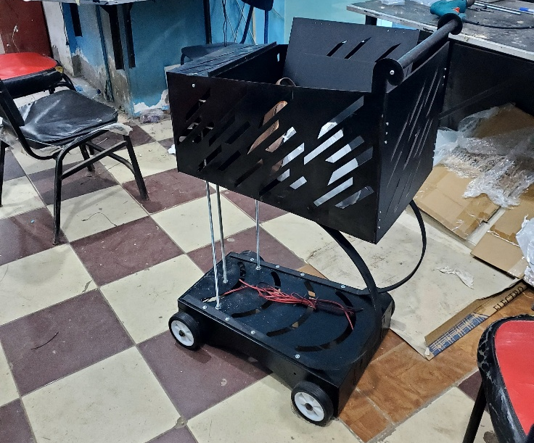
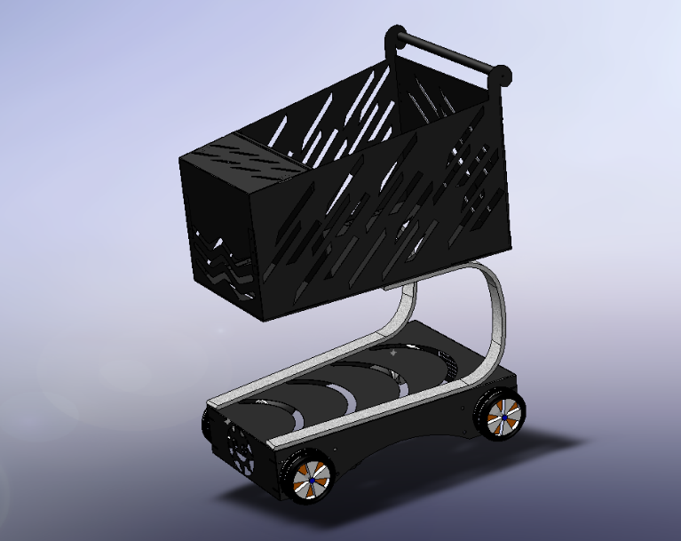
Figure 3.2 Real-View Perspective
Figure 3.1 CAD Perspective

The mechanical design sector is a critical component that encompasses the development and optimization of the cart's structural integrity and functionality. This chapter delves into the design principles, the parts used, materials selection, and fabrication methods employed to create a robust and efficient mechanical system.
Throughout the design process, we prioritized simplicity and efficiency, striving to minimize complexity while ensuring each component contributes effectively to the overall performance of the cart. The interplay of various mechanical parts, including the upper and lower bases, connecting flanges, and fasteners, was carefully considered to facilitate seamless operation and ease of assembly.
We faced several challenges, particularly in achieving precise angles and dimensions for the connecting components. These challenges required innovative solutions and iterative design adjustments to ensure structural stability and functionality. By employing advanced CAD software, we were able to visualize and refine our designs, leading to optimized mechanical solutions tailored to our project's specific needs.
In this chapter, we will explore the detailed design considerations, and the methodologies adopted to overcome design challenges, ultimately resulting in a cohesive and effective mechanical design.

3.1 The Design
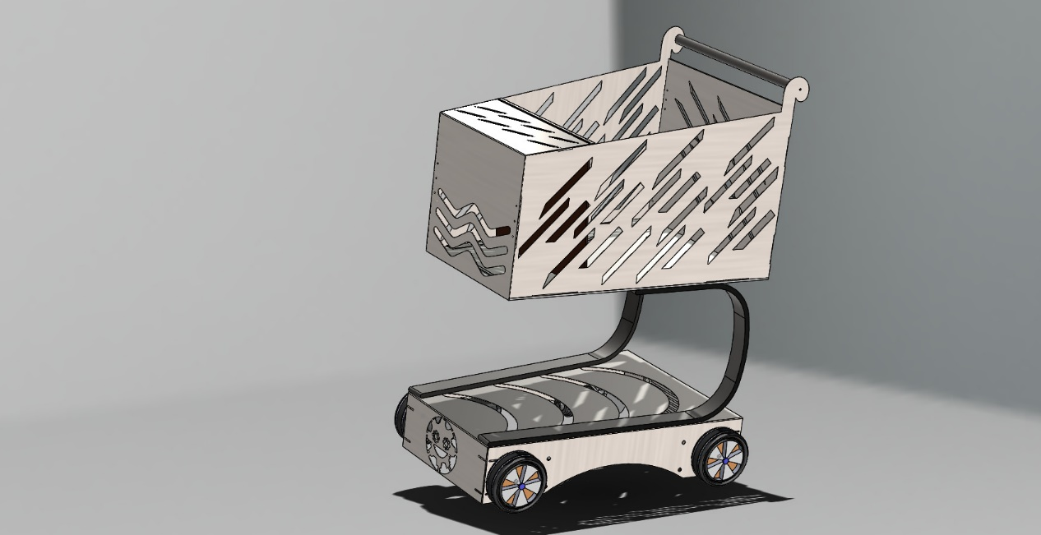
The complete design was developed using SolidWorks software, as shown in Figure 3.3, allowing our mechanical team to efficiently manage and finalize the entire design process. This CAD program enabled us to ensure that each component could be assembled seamlessly during fabrication. We carefully selected the appropriate dimensions for all parts and made necessary cuts or fixtures to guarantee the optimal functionality of the cart. The detailed CAD model in Figure 3.3 demonstrates the integration of structural and mechanical components, ensuring that the design meets the project's functional and practical requirements.

Figure 3.3 Complete Design on SOLIDWORKS

3.1.1 Material Selection for the Prototype
In the development of our prototype, we carefully selected a variety of materials tailored to the specific functions of each component, enhancing overall efficiency.
- The lower section of the cart, as illustrated in Figure 3.4 (bottom view) and Figure 3.5 (top view), bears the majority of the weight and houses the motors and wheels. This section is constructed from sheet metal, a material chosen to ensure maximum strength and stability under heavy loads. The bottom view in Figure 3.4 highlights the placement of the motors and wheels, while the top view in Figure 3.5 provides a clear perspective of how the components are securely mounted to maintain structural integrity and efficient functionality.
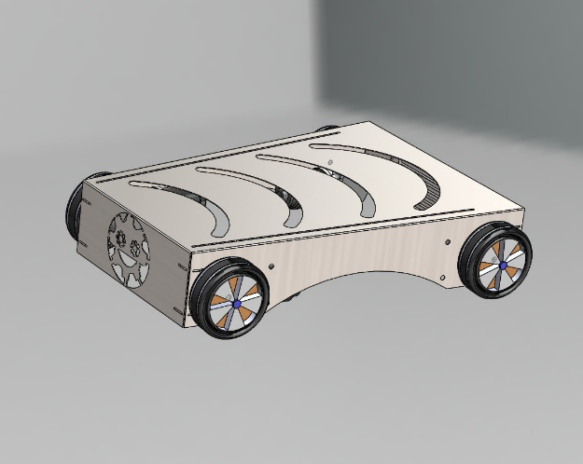
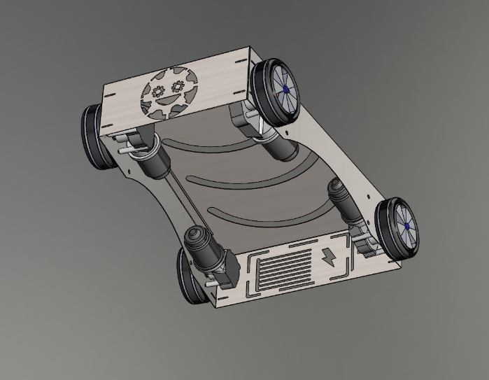
Figure 3.5 Lower part Top View
Figure 3.4 Lower part Bottom View
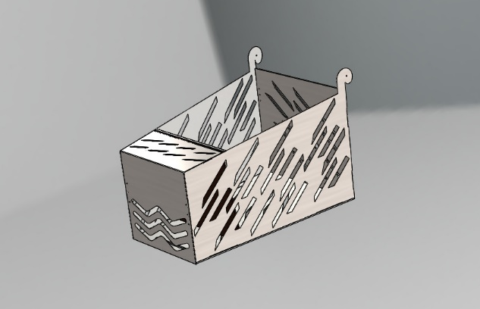
- The upper section of the cart, as shown in Figure 3.6, is comprised of four distinct parts. The two side panels, made from sheet metal, provide additional stiffness to the structure, enhancing its durability. The remaining components are crafted from wood, offering a lightweight yet sturdy platform for securing the electrical components. This combination of materials ensures the safe and organized placement of electronic systems, minimizing the risk of electrical issues and prioritizing user safety.
Figure 3.6 The Upper Part of the Cart
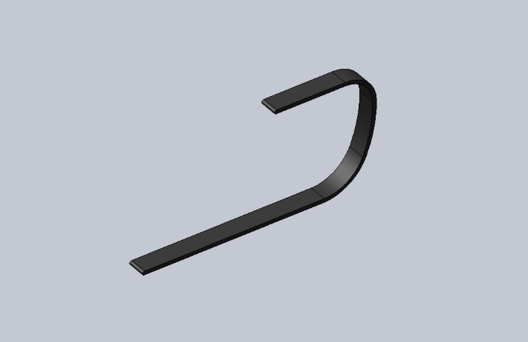
- The linking part, as depicted in Figure 3.7, serves to facilitate support between the upper and lower sections of the cart. To achieve this, we incorporated curved steel welded rods, which provide strength and flexibility, along with two screws to securely fasten the front part of the cart. This design ensures a stable connection between the sections, maintaining structural integrity while accommodating the mechanical and functional requirements of the cart.

Figure 3.7 The Linking Part

- A holder was integrated to allow for the organized routing of wires and connections between the upper and lower sections. Figure 3.8, the side view of the cart, provides an overall perspective of how the sections are structured and connected, highlighting the streamlined design that accommodates the wiring setup.
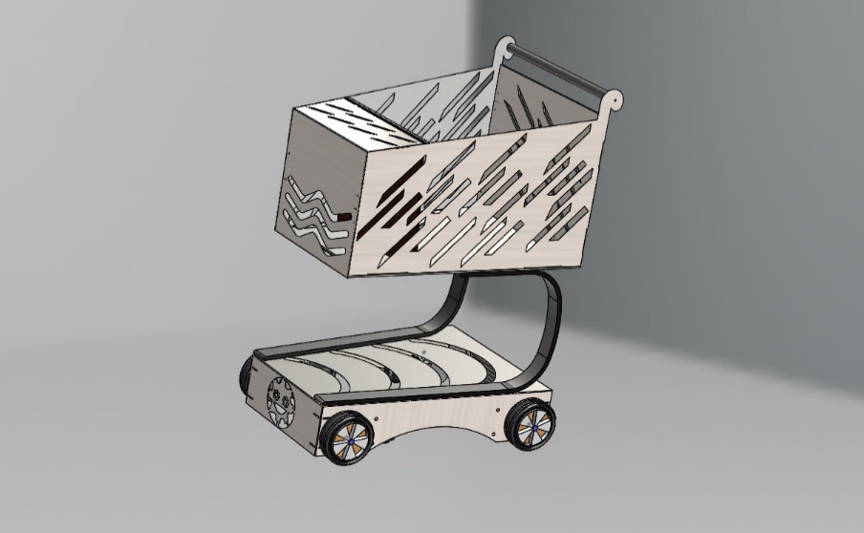

Figure 3.8 The Side View of The Cart

3.1.2 Designing the dimensions
Regarding our prototype, we conducted an analysis of industry-standard carts and found that they typically have a load capacity of 100 to 150 kg, with the cart's weight ranging from approximately 16 to 20 kg. Additionally, the interior volume of these carts spans from 60 to 150 liters, effectively accommodating the intended load.
Our project dimensions, as detailed in Figure 3.9, are 600 × 820 mm with a weight of 20 kg, which aligns closely with market standards. In selecting these dimensions, we considered various specifications, including the average height of an adult user, to ensure optimal usability and comfort. This consideration is essential for facilitating ease of access and maneuverability.
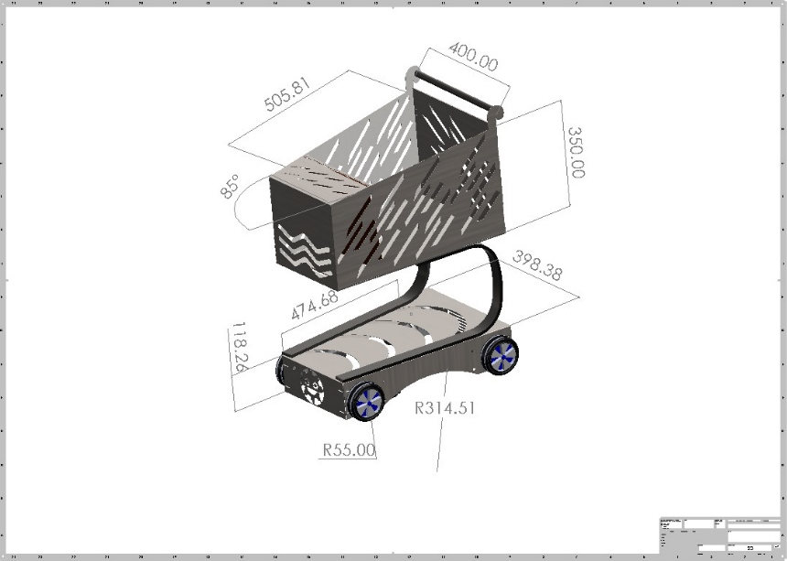
To maximize the storage capacity for user purchases, we designed the cart to be highly user-friendly. The hardware component box is strategically positioned at the front of the cart, allowing for increased storage space both within the cart and above the base. This thoughtful arrangement enhances the cart's functionality, ensuring that users can efficiently organize and access their items during transport.
Figure 3.9 Detailed View for the dimensions of the cart

3.2 Mechanical components
During the design process, we prioritized simplifying fabrication by creating a model that required the fewest possible components while focusing solely on those essential for optimal functionality. This careful selection allowed us to streamline manufacturing, reduce costs, and minimize assembly time. All parts were meticulously designed using advanced CAD (Computer-Aided Design) software, enabling precise 3D modeling and early identification of potential design flaws. This approach ensured that every component included played a crucial role, eliminating unnecessary elements that could complicate assembly or increase weight.
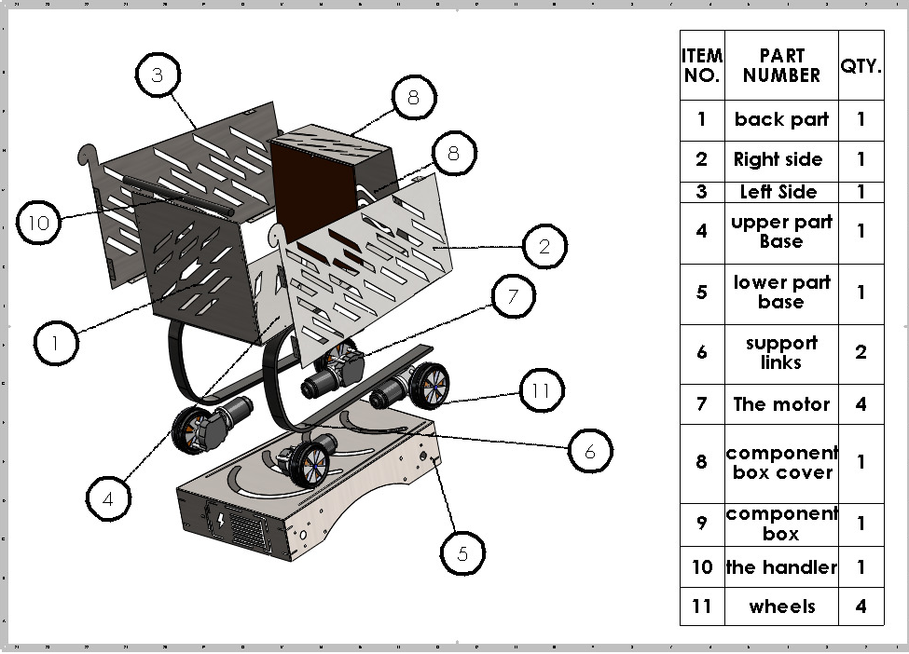
In addition to the primary components, we incorporated various fasteners, corners, spacers, nuts, and couplers to guarantee robust assembly and reliable performance. Figure 3.10 provides a detailed description of the components used in the design, showcasing the high-quality fasteners securing connections between parts, corners and spacers maintaining proper alignment and spacing, and motor couplers specifically designed to create a secure connection with the wheels, facilitating efficient power transfer. By adopting this focused design strategy, we created a streamlined and efficient model that meets user needs while remaining easy to assemble and maintain, ultimately enhancing performance and contributing to a more sustainable manufacturing process.

Figure 3.10 detailed description for the components used

3.2.1 Back Part

For the rear and base sections of the upper part, we selected wood as the primary material due to its insulating properties. This choice allows us to house the necessary hardware components while strategically incorporating cuts to minimize weight, thereby enhancing the cart's mobility and ease of control. Figure 3.11 presents the back side of the upper part, providing a clear view of how the wood material is utilized to securely house the components while maintaining a lightweight and efficient design.
The rear component features a thickness of 4 mm, with dimensions of 350 mm x 400 mm.

Figure 3.11 Back Side of the Upper Part

3.2.2 Right Side
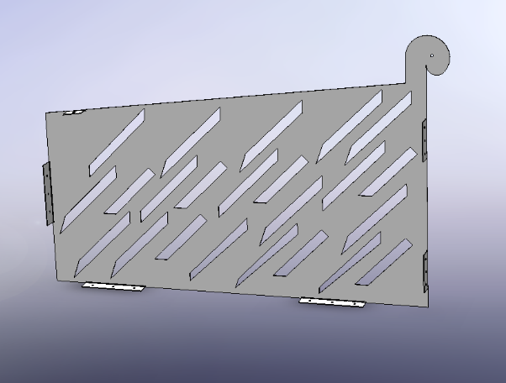
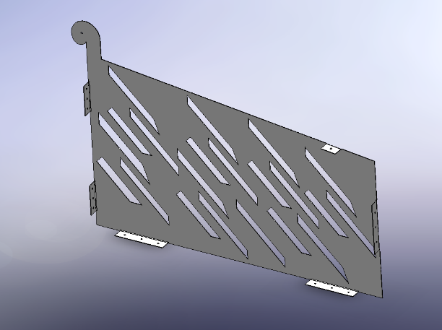
The left and right sides of the upper section are constructed from 1 mm thick sheet metal, featuring flanges that securely connect the components. These sides also incorporate cuts to further reduce weight without compromising structural integrity. Figure 3.12 illustrates the right side of the upper part, while Figure 3.13 shows the left side, both highlighting the precise design and the strategic cuts made to minimize weight. To accurately design the sides, we created individual drawings for each part to accommodate the specific angles used in the base of the upper section. For more details, please refer to section 3.2.3, which discusses the upper part's base.
Figure 3.12 The Right Side of the Upper Part
Figure 3.13 The Left Side of the Upper Part

3.2.3 Upper Part Base
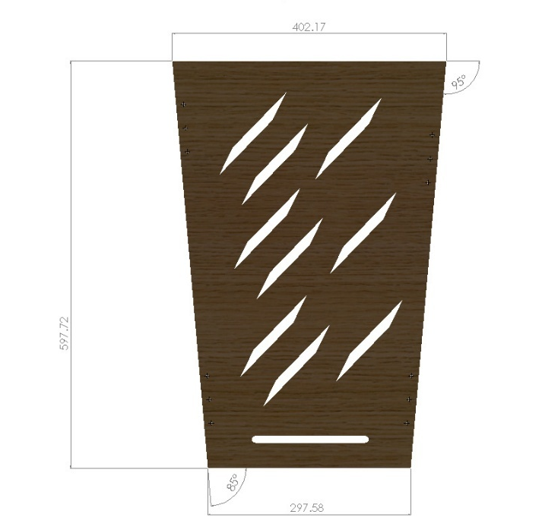
The base of the upper section is designed in accordance with the dimensions specified in Figure 3.14. We incorporated angles to enhance the smooth movement and overall functionality of the cart. Additionally, a cut was included at the end of the part to create a pathway for the wires that connect the control systems between the upper and lower sections of the cart.
During the design phase of the base of the upper part of the cart, we faced several challenges, primarily due to the angles of the sheet metal used. These angles complicated the dimensioning of the connecting flanges and the alignment of other components, which was crucial for ensuring structural integrity and functionality.
One of the main difficulties was achieving precise measurements for the flanges, as the angles introduced complexity in both the cutting and assembly processes. Misalignment could lead to structural weaknesses, affecting the overall performance of the cart. To address this issue, we utilized advanced CAD software to create detailed models that accurately represented the dimensions and angles. This allowed us to visualize the assembly before physical fabrication, reducing the risk of errors.

Figure 3.14 The Base of the Upper Part
We also collaborated closely with our fabrication team to ensure that the manufacturing processes could accommodate the specific angles and dimensions we had devised. Their insights were invaluable in adjusting our designs to meet practical constraints, allowing for smoother assembly and enhanced stability.

3.2.4 Lower Part Base
For the base of the lower section, we selected galvanized steel with a thickness of 1.5 mm to ensure it can withstand the total weight of the cart, including the motors, while maintaining structural integrity under various conditions. We integrated corner supports between the sides of the base to prevent widening gaps and enhance stability. The design features an access box that opens from the bottom and closes from the top (as illustrated in Figure 3.15, shown in an inverted position for clarity), allowing users to utilize the space between the upper and lower sections as additional storage.
To optimize the weight of the lower part without compromising strength, we incorporated various shapes and strategic cuts for wire routing from the upper section to the motors.
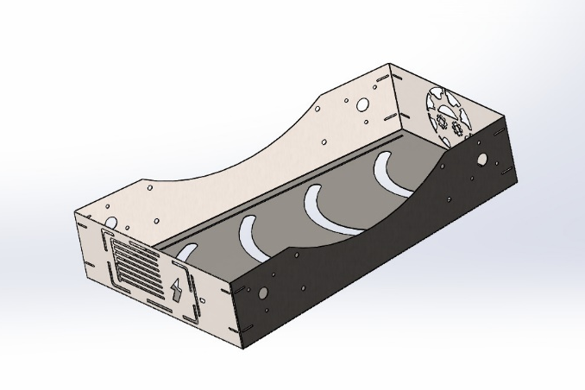

Figure 3.15 The Lower part of the Cart
The sides were meticulously measured to accommodate the specifications of the motors, ensuring they are securely mounted to minimize vibrations that could affect the cart's maneuverability. Each motor is positioned to maintain an equal distance from the ground across all wheels.

3.2.5 Support Links
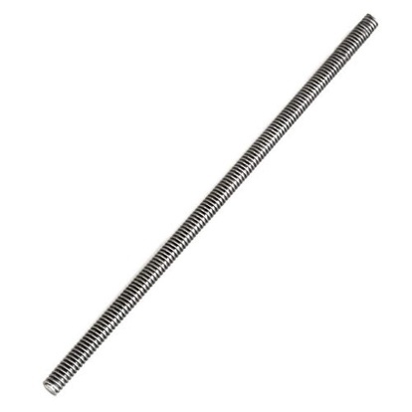

For connecting the two parts together, we used sheets made of steel welded in the shape of an arc to give the cart a smooth look, in addition to providing stability and support. Figure 3.16, "Connecting Links," illustrates this arc-shaped design. In addition to this, we used three screws to secure the front of the cart, preventing vibrations and ensuring it stays in place during maneuvering. Figure 3.17, "Threaded Rods," shows the threaded rods used to secure the structure and reinforce its alignment. We also incorporated a third steel guide to carry the wires through the path from the upper to the lower part, ensuring proper cable management throughout the cart's design.

Figure 3.17 Threaded Rod
Figure 3.16 Connecting Links

3.2.6 The Motor
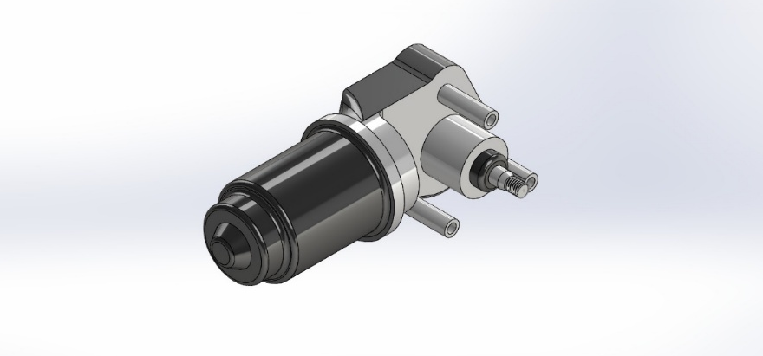
While searching for a motor for our project, the choice of a wiper motor was pivotal due to its specific operational characteristics and suitability for our design requirements. The wiper motor is primarily used in automotive applications to control the windshield wipers, which means it is engineered for durability and consistent performance under varying conditions. Figure 3.18, "The Wiper Motor," illustrates the motor selected for our project, highlighting its compact design and robustness, which align perfectly with the cart’s functional needs.

Figure 3.18 The Modeled Motor

3.2.7 Methodology of searching
For the methodology to select the motor we had searched for some criteria as:
- Torque and Power: Wiper motors are designed to deliver sufficient torque to overcome the resistance encountered during operation. This characteristic makes them ideal for applications requiring reliable movement, such as driving wheels in our design the model we used gives total Torque of
T-total = 4×20 = 80 Nm
- Compact Size: The compact nature of wiper motors allows for easy integration into our project without adding excessive weight or bulk. This was particularly important in maintaining the overall design aesthetics and functionality of the cart.
- Cost-Effectiveness: Wiper motors are generally cost-effective, making them a budget-friendly option for our project. This allowed us to allocate resources effectively while still ensuring high-quality components.
- Availability: Wiper motors are widely available and can be sourced easily from various suppliers. This accessibility facilitated timely procurement and reduced potential delays in the project timeline.
- Versatility: The design of wiper motors allows for versatility in mounting and operation. We were able to adapt the motor's configuration easily to fit our specific mechanical setup, ensuring optimal performance.
- Robustness: Designed to withstand harsh environmental conditions, wiper motors exhibit excellent resilience against moisture and debris. This robustness is crucial for the longevity of our project, especially if it is to be used in varying operational environments.
By selecting a wiper motor, we ensured that our project not only met the required performance standards but also maintained efficiency and reliability throughout its operational life. The combination of these factors made the wiper motor an optimal choice for our mechanical design, aligning perfectly with our project goals.

We also calculated the maximum weight it can handle to be considered while using the cart:
- F = T-total / r
F = 80 / 0.13 ≈ 615.38 N
Knowing that the wheels we used are of 0.13 m radius
Convert the total force into mass:
- m = F / g
then, m = 615.28 / 9.81 = 62.7 kg
So, we can conclude that with motors of 20 Nm torque each, the cart's maximum weight is approximately 62.7 kg for the motors to operate effectively. Figure 3.19, "The Used Motor," provides a visual representation of the motor chosen, demonstrating its capacity and design tailored to handle the cart's weight while ensuring optimal performance.
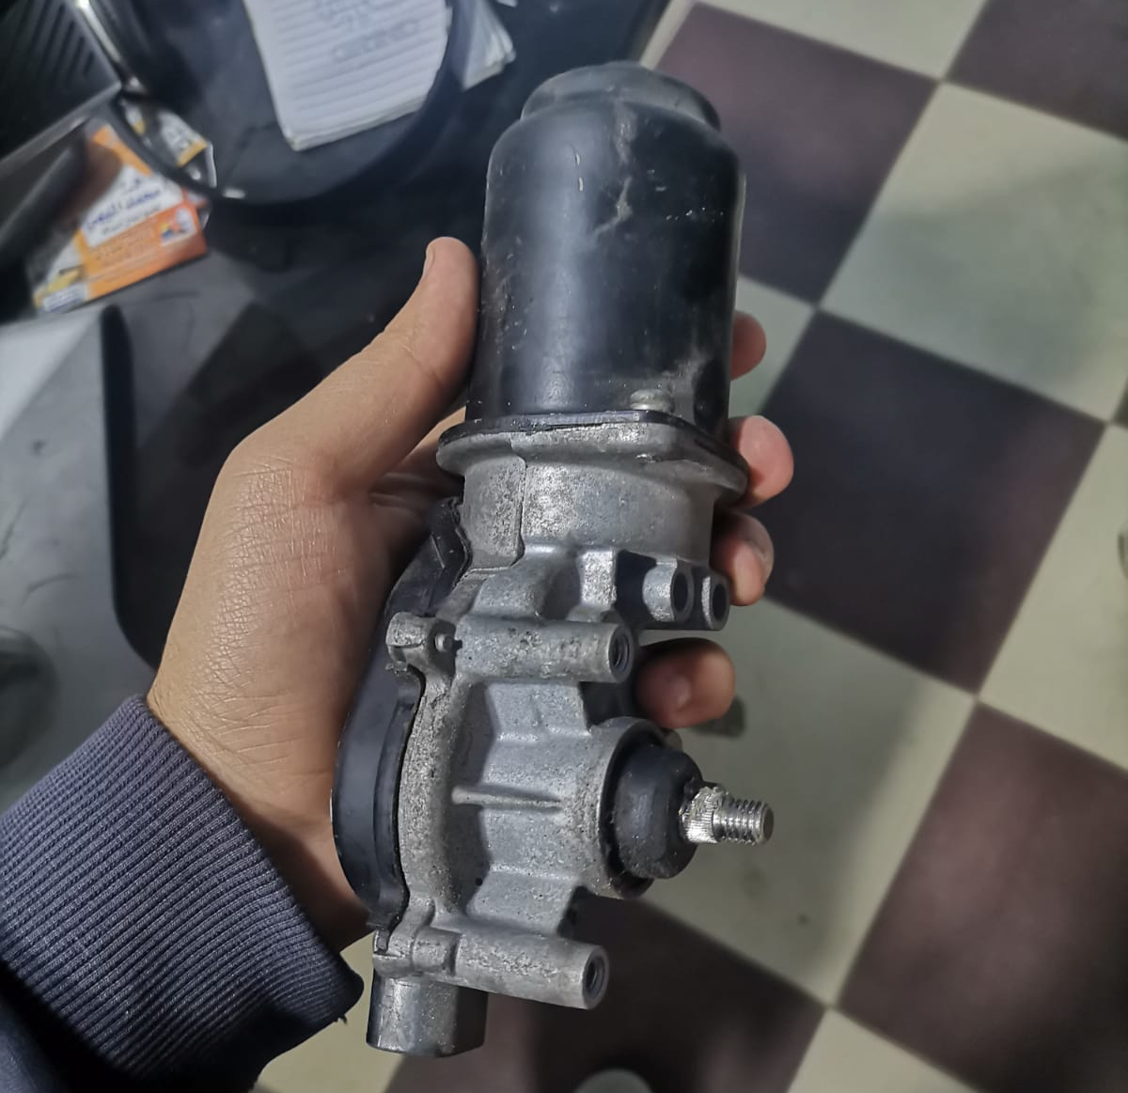

Figure 3.19 The Used Motor

3.2.8 The Component Box Cover
The inclusion of the component box cover in our design was driven by the need for accessibility and efficient maintenance of the hardware. This cover serves several crucial functions that enhance both the functionality and usability of the cart. Figure 3.20, "Clarifying the Opening of the Component Box," illustrates the design for easy access to the hardware inside, while Figure 3.21, "Clarifying the Closing of the Component Box," shows how the cover securely closes to protect the components, ensuring both safety and convenience for the user.
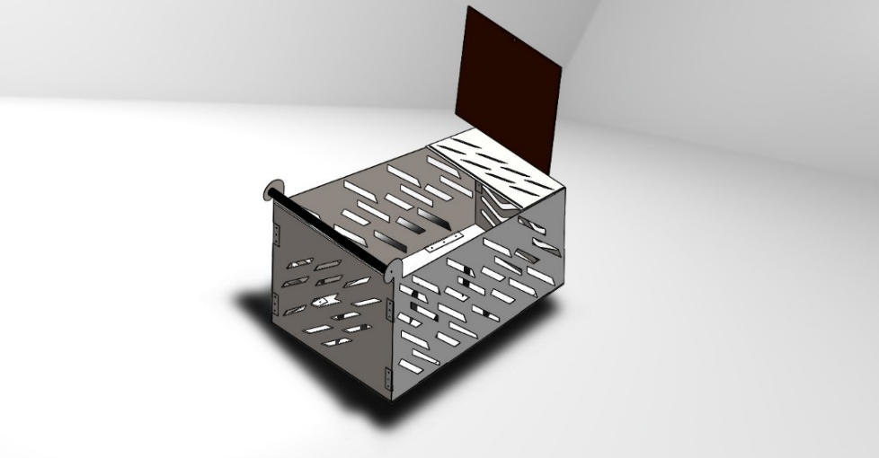
- Ease of Access: The component box cover allows for quick and easy access to the internal components of the cart. This design feature is particularly beneficial for troubleshooting, repairs, and routine maintenance. By simplifying access, we reduce the downtime associated with addressing technical issues.

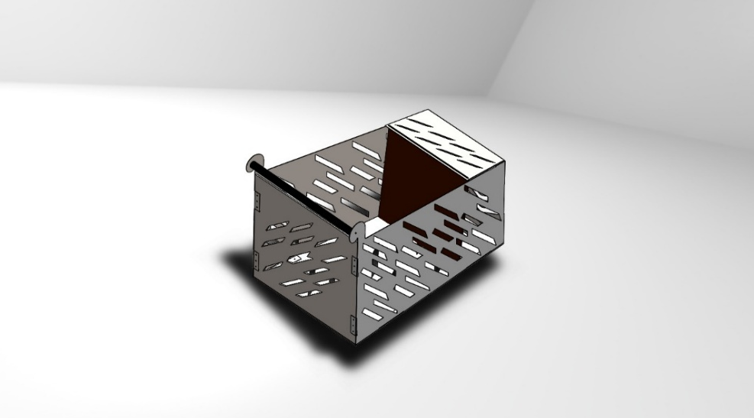
Figure 3.20 Clarifying the opening of the component box
Figure 3.21 Clarifying the closing of the component box
- Organized Storage: By compartmentalizing the hardware within the component box, we created a designated space that separates the electronic components from the rest of the storage area. This organization minimizes the risk of damage to sensitive components and keeps everything tidy, making it easier to locate specific parts when needed.
- Facilitated Maintenance: Regular maintenance is essential for ensuring the longevity and performance of the cart. The component box cover allows users to quickly inspect, clean, or replace components without requiring extensive disassembly of the entire system. This ease of maintenance encourages proactive care and enhances the overall reliability of the cart.
- Protection from Environmental Factors: The cover also serves to protect the internal components from dust, moisture, and other environmental factors that could potentially compromise their functionality. By shielding the components, we enhance their durability and reduce the likelihood of failures caused by external influences.
- User-Friendly Design: The thoughtful design of the component box cover contributes to an overall user-friendly experience. Whether for maintenance staff or end-users, the ability to easily access and manage the components fosters confidence in the system's reliability and performance.

3.2.9 The Component Box
The component box is a critical element of our design, meticulously crafted to securely house all essential components of the cart. Its thoughtful design not only provides structural integrity but also facilitates optimal organization and insulation between different hardware elements.

- Design Features and Functionality
- Three-Shelf Structure: The component box features three distinct shelves, each designed to hold specific components securely. This tiered arrangement maximizes space efficiency while ensuring that each component is easily accessible. The vertical layout allows for organized storage, preventing clutter and confusion.
- Material Selection: Each shelf is constructed from high-quality wood, chosen specifically for its insulating properties. Wood serves as an effective insulator, reducing the risk of electrical interference between components. This is particularly important for maintaining the integrity of sensitive electronics, ensuring reliable performance.
- Optimal Component Placement:
  - Top Shelf: The top shelf is designated for the camera, which is essential for capturing real-time data and providing visual feedback. Its elevated position allows for an unobstructed field of view, enhancing the functionality of the cart.
  - Middle Shelf: Below the camera, the middle shelf houses the various controllers. This strategic placement ensures that the controllers are easily accessible for adjustments or troubleshooting while remaining insulated from the camera above.
  - Bottom Shelf: The bottom shelf is reserved for the batteries, providing a stable base for the power source. Keeping the batteries at the bottom not only offers better weight distribution but also helps in managing heat dissipation, which is crucial for maintaining battery health.
- Ease of Maintenance: The organized layout of the component box simplifies maintenance tasks, allowing users to quickly identify and access specific components as needed. This design reduces the time and effort required for repairs or replacements, promoting a proactive maintenance approach.
- Durability and Protection: The robust construction of the component box ensures that all housed components are well-protected from physical damage and environmental factors. The insulated shelves contribute to the longevity of the electronics, safeguarding them against wear and tear.

3.2.10 The Handle

The handle is an essential feature of our cart, designed with both functionality and user comfort in mind. Its specifications and construction elements play a significant role in ensuring an optimal user experience during operation. It was thoughtfully designed to enhance the user experience by prioritizing comfort, control, and aesthetic appeal. Its dimensions, material choice, and ergonomic design make it a crucial element for effectively driving the cart while ensuring the user's comfort and safety. Figure 3.22, "The Handle of the Cart," provides a detailed view of the handle, highlighting its design and integration into the cart's overall structure.

Figure 3.22 The handle of the cart
- Design Specifications:
- Dimensions: The handle is designed as a wooden cylinder with a diameter of 20 mm and a length of 400 mm. This size strikes a balance between robustness and ease of grip, making it suitable for various user hand sizes.
- Material Choice: Crafted from high-quality wood, the handle not only provides a natural aesthetic but also offers a warm and comfortable grip. Wood is known for its durability and strength, ensuring that the handle can withstand continuous use without compromising its integrity.
- User Comfort: The cylindrical shape and appropriate diameter enhance the comfort of the user while driving the cart. The handle's design allows for a natural hand position, reducing strain during prolonged use. This ergonomic consideration is crucial for minimizing fatigue, especially in scenarios where the cart is operated over extended periods.
- Grip Texture: The smooth finish of the wooden handle provides a comfortable grip, while the natural texture of the wood helps prevent slipping, even in varying environmental conditions. This feature ensures that users have reliable control over the cart, enhancing safety during operation.
- Stability and Control: The length of the handle provides adequate leverage, allowing users to maneuver the cart with ease. A longer handle enables better control, especially when navigating tight spaces or making sharp turns.

3.2.11 Wheels and couplers
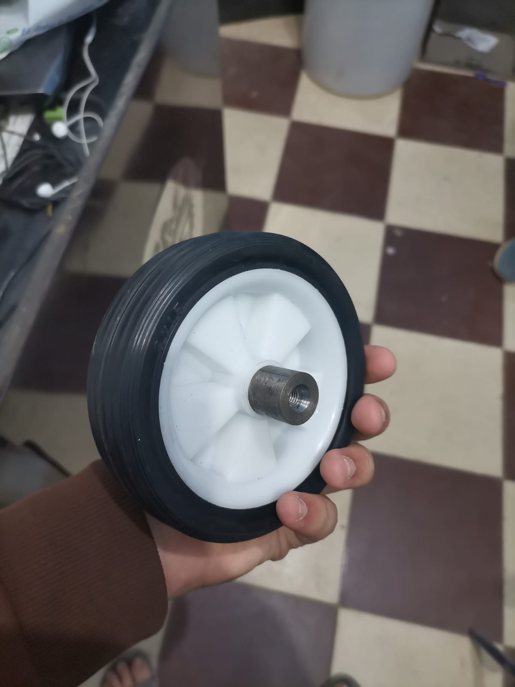
The wheels and couplers are integral components of our cart, designed to ensure smooth mobility and a robust connection to the motor. Their specifications and construction methods contribute significantly to the overall performance and functionality of the cart. Figure 3.23, "The Wheel and the Coupler," illustrates the design and integration of these components, highlighting their role in facilitating seamless movement and efficient power transfer from the motor to the wheels.

Figure 3.23 The Wheel and the Coupler
- Wheel Specifications
- Diameter and Material: The wheels have a diameter of 13 cm, which strikes an ideal balance between stability and maneuverability. This size allows for smooth movement across various surfaces, making the cart versatile for different operational environments.
- Design Features: The wheels are designed to provide optimal traction and durability. Their construction materials are selected to withstand wear and tear, ensuring longevity even under continuous use. The tread pattern on the wheels enhances grip, allowing the cart to maintain stability and control during movement.
- Mobility: The size and design of the wheels facilitate easy navigation, whether on flat surfaces or uneven terrains. This capability is crucial for ensuring that users can operate the cart effectively in diverse settings. Figure 3.24, "The Other Side of the Wheel," offers a view of the wheel's opposite side, showcasing its structural design and material details.
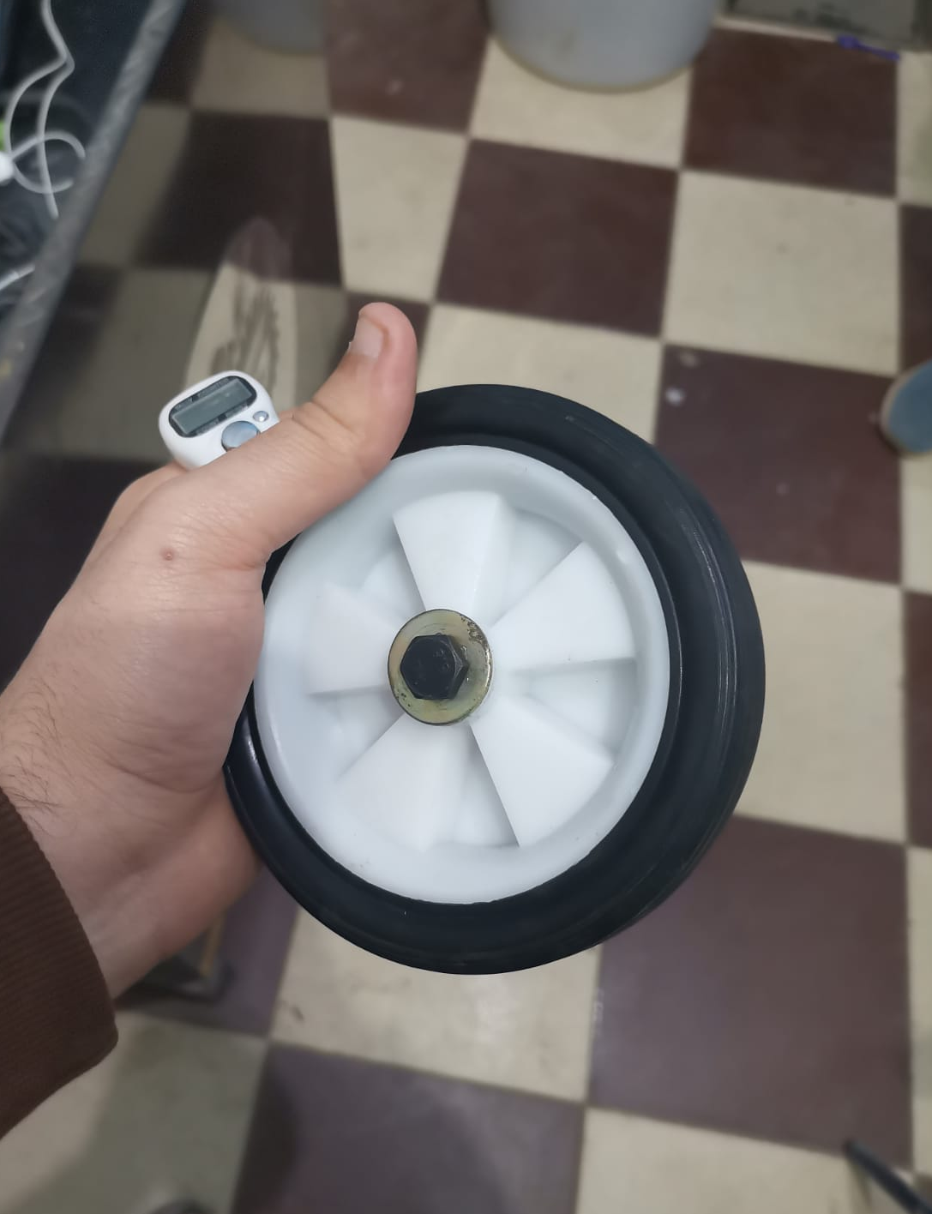
Figure 3.24 The other side of the wheel

- Coupler Design:
- Material and Fabrication: The coupler is made of steel, providing superior strength and durability. It is crafted using a lathing machine, which ensures precision in its dimensions and fit. This process allows for a high-quality finish and accurate tolerances, essential for the coupler's functionality.
- Functionality: The coupler serves as the connection point between the motor shaft and the wheels. It is designed to be securely screwed onto the motor shaft, providing a robust interface that transmits power efficiently. This secure connection is vital for ensuring that the wheels respond properly to the motor's output, enabling smooth operation of the cart.
- Ease of Installation: The design of the coupler facilitates straightforward installation and maintenance. Users can easily attach or detach the coupler from the motor shaft, allowing for efficient repairs or replacements without significant downtime.

- Overall Integration
The combination of the 13 cm wheels and the steel coupler creates a reliable and efficient system for the cart. The wheels provide the necessary mobility and stability, while the coupler ensures a secure and effective connection to the motor. Together, they enhance the cart’s overall performance, making it a versatile tool for various applications. This thoughtful design approach ensures that users can navigate their environments with confidence and ease, maximizing the cart's utility.

3.3 The Difficulties We Faced

3.3.1 Mounting the Motor
One of the significant challenges we faced during the mechanical design phase was the precise mounting of the motors. Each motor required a specific design to ensure it was securely fixed in the correct position. This was crucial for maintaining uniformity in the spacing between the wheels and the ground.
The complexity arose from the fact that the fixation points for the motors varied in dimensions, particularly when the assembly was flipped. This inconsistency necessitated meticulous planning and measurement to ensure that all motors were aligned correctly, thereby preventing any discrepancies that could affect the cart's stability and maneuverability.
To overcome these challenges, we implemented a systematic approach to dimensioning the motor fixation points. This involved careful consideration of the angles and distances during the design process, ensuring that each motor was tailored to fit seamlessly within the overall structure.
Our methodology was that we fixed the place of the wheels throughout the design, then from it, we started to add the motors in the assembly one by one, positioning them as they would be in real life so we could determine the exact place for the cut we needed to fix it in position securely on the side of the base.
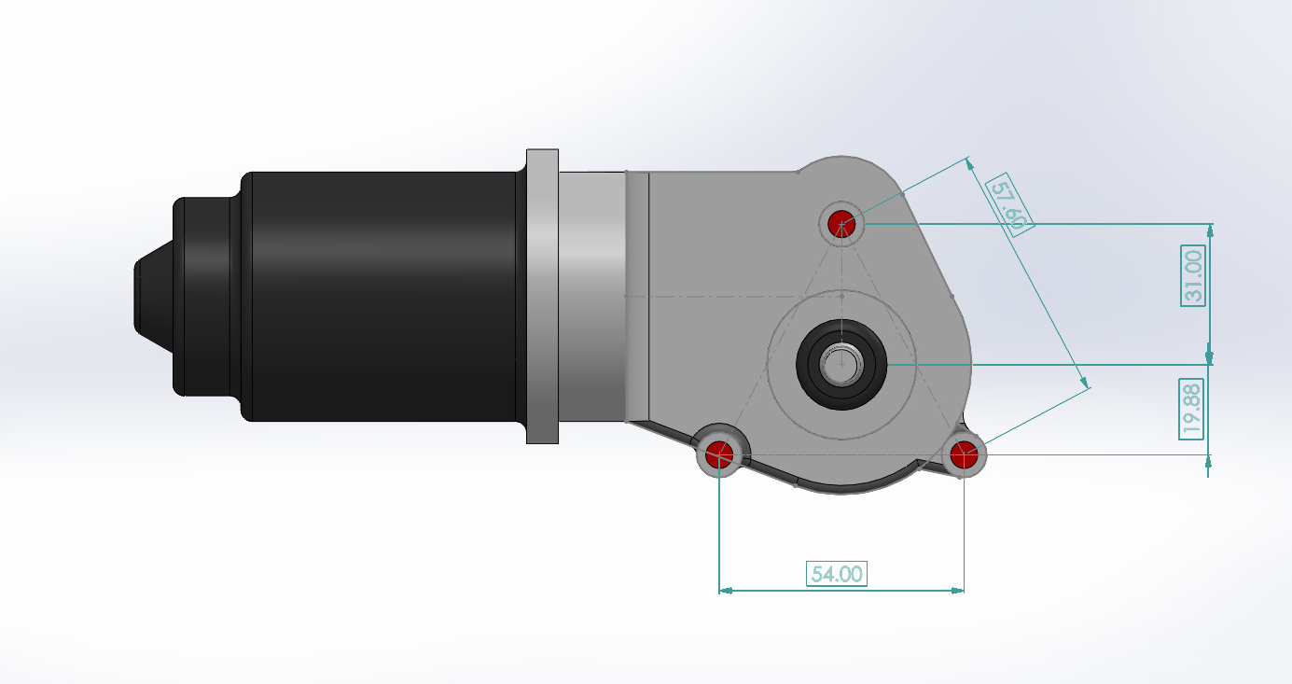
Through this dedicated effort, we successfully achieved a robust mounting system that not only secured the motors effectively but also contributed to the overall performance and reliability of the cart (Figure 3.25: The dimensions of the motor).
Figure 3.25 The dimensions of the motor
One significant challenge we encountered during the mechanical design phase that was also related to the placement of the motors in relation to the cart's body and wheels was that the designated fastening points for the motors were positioned farther away from the wheel assembly than anticipated. This discrepancy resulted in a noticeable gap between the motors and the cart's body, which posed a risk of instability and misalignment during operation.
To address this issue, we needed to devise a solution that would effectively bridge the distance between the motors and the body. After careful consideration, we opted to incorporate nuts onto the bolts used for fastening the motors. These nuts acted as spacers, allowing us to adjust the height and position of the motors to ensure they were securely fastened and aligned correctly with the wheel assembly.
By using nuts as spacers, we were able to achieve a snug fit that minimized the gap, thereby enhancing the overall stability and functionality of the cart. This solution not only resolved the immediate challenge but also contributed to a more robust design, ensuring that the motors operated efficiently without risking any misalignment during movement.

3.3.2 Wiring
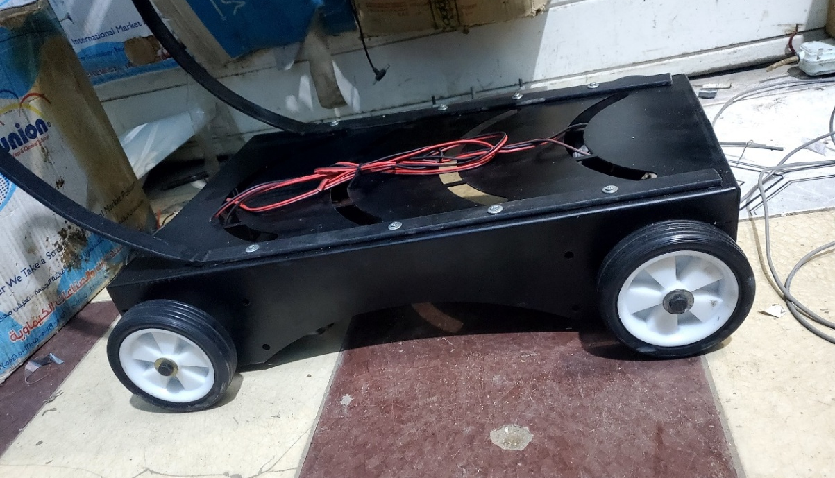
Wiring is a critical aspect of our cart’s design, and while we aimed for efficiency and organization, we encountered several challenges during the process. To address these difficulties, we implemented specific design features that facilitated a more streamlined wiring setup (Figure 3.26: Wiring of the lower part).

Figure 3.26 Wiring of the lower part
- Identifying Wiring Challenges:
- Complex Routing: One of the primary difficulties was the complex routing of wires from the camera, positioned at the highest point of the design, down to the wheels at the bottom. Ensuring that wires were not only connected properly but also neatly arranged to avoid entanglement was a considerable challenge.
- Limited Space: The confined spaces within the cart made it difficult to maneuver wires without risking damage to other components. This necessitated careful planning to determine optimal pathways for the wiring, ensuring that all connections were secure while avoiding clutter.
- Accessibility: Ensuring that wires remained accessible for maintenance or troubleshooting was another challenge. Once the cart was assembled, accessing certain wires for adjustments or replacements could become cumbersome.
- Design Solutions
- Wiring Guides: To facilitate the wiring process, we created dedicated guides that allowed for the organized passage of wires throughout the cart. These guides helped ensure that wires could be routed efficiently from one component to another, minimizing the risk of tangling or damage.
- Strategic Cuts: We incorporated several strategically placed cuts in both the upper and lower parts of the cart. These cuts served as designated pathways for the wires, allowing us to thread them securely without compromising the integrity of the design. By providing these openings, we simplified the wiring process, making it easier to pass wires from the camera down to the wheels.
- Modular Design: The modular nature of the wiring system allowed for easier assembly and disassembly. This design choice made it simpler to make adjustments or repairs without needing to dismantle the entire cart.
Despite the initial challenges, the solutions we implemented ultimately enhanced the overall efficiency of the wiring process. The combination of the wiring guides and strategic cuts allowed for a clean and organized setup, reducing potential issues during operation. Furthermore, these design features have contributed to the cart's reliability, ensuring that all components function harmoniously while remaining accessible for future maintenance. Through careful planning and innovative design, we were able to overcome the difficulties faced during the wiring phase, resulting in a well-structured and user-friendly system.

Chapter 4
Hardware Implementation

4. Hardware Implementation

4.1 Introduction
The hardware implementation of the "Automated Follow-Me Cart Using AI and Computer Vision" forms the backbone of the project, translating conceptual designs into a functional prototype. This chapter delves into each hardware component’s specifications, selection rationale, integration methodology, and performance considerations. By combining mechanical engineering with advanced electronics, the project achieves a robust and versatile solution tailored for assistive mobility.

4.2 Detailed Analysis of Hardware Components

4.2.1 Motors
- Type and Specifications:
  - Wiper motors were selected for their proven reliability in automotive applications, ensuring consistent performance under varying loads and environmental conditions.
  - Specifications:
    - Rated Torque: 20 Nm per motor.
    - Maximum Operating Voltage: 12V.
    - Operating Current: 4-5A underload.
    - Motor Efficiency: Approximately 85%.
- Functionality and Role:
  - The motors drive the cart’s wheels, providing smooth and stable movement across various terrains.
  - Designed to handle weights up to 62.7 kg, accommodating the cart’s structure and additional load from user belongings.

- Integration:
  - Mounted on a steel chassis with vibration-damping pads to minimize noise and mechanical wear.
  - Connected to motor drivers through custom-designed couplers for efficient torque transmission.
- Challenges and Solutions:
  - Precise alignment of the motors with the wheel shafts was critical to avoid uneven wear. Custom brackets with adjustable slots were fabricated to ensure perfect alignment.
  - Heat dissipation during extended use was addressed by incorporating passive cooling fins on the motor housing.

4.2.2 Motor Drivers
Motor drivers play a crucial role in the Smart Shopping Cart, acting as the intermediary between the microcontroller and the motors, ensuring smooth and efficient operation.

- Functionality
- Speed and Direction Control:
  - The motor drivers enable precise speed and direction control, allowing the cart to execute essential commands such as forward movement, turning, and stopping.
- Pulse Width Modulation (PWM):
  - PWM signals from the Arduino Nano are processed by the motor drivers to achieve accurate control over motor speed and torque, providing responsive and smooth operation.

Specifications
- Dual-Channel H-Bridge Design:
  - Each driver features a robust H-bridge circuit capable of handling up to 20A per channel, ensuring sufficient power for the cart's motors under various load conditions.
- Current Protection Circuits:
  - Built-in current protection safeguards the motors and electronics from overloads and short circuits, enhancing the system's reliability and longevity.

Integration
- PCB Mounting:
  - The motor drivers are securely mounted on a custom-designed PCB (Figure 4.1) that includes heat sinks for effective thermal management during extended operations.
- Connection to Arduino Nano:
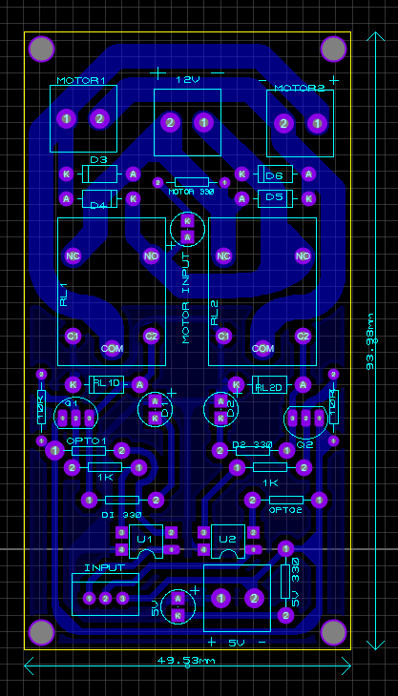
  - Signal inputs from the Arduino Nano are directly interfaced with the motor driver, ensuring seamless communication.
  - The use of PWM signals provides precision in speed adjustments and smooth transitions between directional changes.

Figure 4.1 Motor Driver Layout

Visual Representation
- Figure 4.1: Motor driver layout illustrating the dual-channel H-bridge design and integration with cooling mechanisms.
- Figure 4.2: A 3D model of the motor driver, showcasing its compact design and how it integrates with the cart's overall hardware system.
- Figure 4.3: Schematic view of the motor driver circuit, highlighting the connections and functional components.
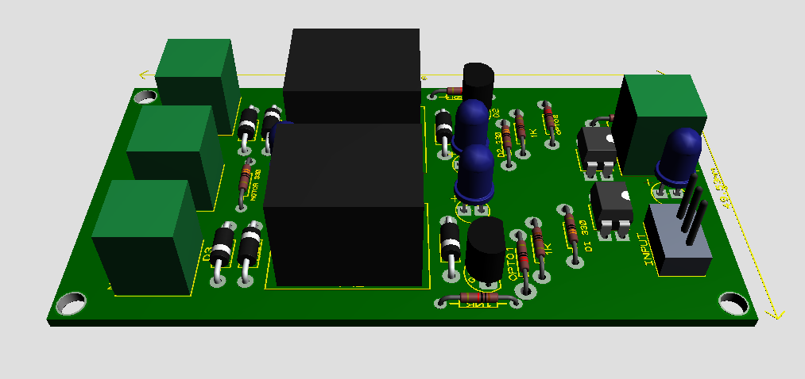
By employing these motor drivers, the Smart Shopping Cart achieves reliable and responsive movement, ensuring it can perform its tasks efficiently in real-world scenarios. The integration of safety features and precise control mechanisms further enhances the cart's performance and robustness.

Figure 4.2 3d Model for Motor Driver
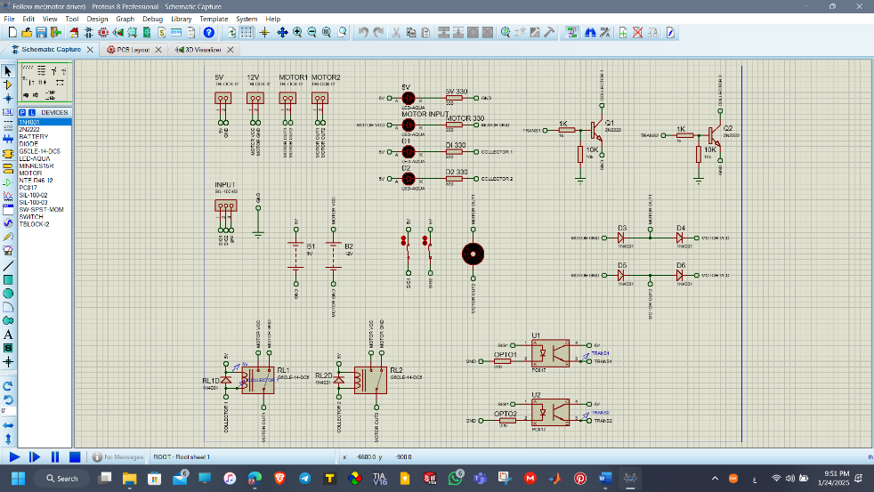

Figure 4.3 Schematic View for Motor Driver

4.2.3 Sensors
Sensors are integral to the Smart Shopping Cart, ensuring accurate obstacle detection and enabling safe navigation. The system incorporates both infrared (IR) and ultrasonic sensors for complementary detection capabilities.

Infrared (IR) Sensors
- Specifications:
  - Detection Range: 10 cm to 2 m.
  - Operating Voltage: 5V.
  - Response Time: <1 ms.
- Role in the System:
  - IR sensors detect nearby obstacles and provide real-time feedback to the microcontroller. This functionality is critical for navigating crowded or cluttered environments safely.
- Placement:
  - One IR sensor is mounted at the front for forward obstacle detection.
  - Two additional IR sensors are positioned at the sides to enhance peripheral awareness.
- Calibration and Optimization:
  - Thresholds were calibrated during testing to minimize false positives caused by varying lighting conditions.
  - Signal processing algorithms were implemented to filter out noise and improve detection accuracy.
- Illustration:
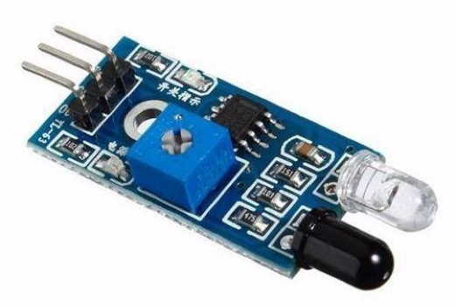
  - Figure 4.4 shows the layout of an IR sensor used in the system.

Figure 4.4 IR Sensor

Ultrasonic Sensors
- Specifications:
  - Detection Range: 2 cm to 4 m.
  - Operating Voltage: 5V.
  - Accuracy: ±3 mm.
- Role in the System:
  - Ultrasonic sensors complement IR sensors by providing longer-range obstacle detection. They are especially effective in scenarios where lighting conditions may impact IR sensor performance.
  - These sensors ensure precise distance measurement and help in detecting obstacles at varying heights.
- Placement:
  - Ultrasonic sensors are mounted at the front and rear of the cart to provide 360-degree coverage for obstacle detection and collision prevention.
- Calibration and Optimization:
  - The sensors were tuned for maximum sensitivity and accuracy during testing.
  - Advanced filtering techniques were used to eliminate false readings caused by sound reflection from nearby objects.
- Illustration:
  - Figure 4.5 shows the layout of an Ultrasonic sensor used in the system.
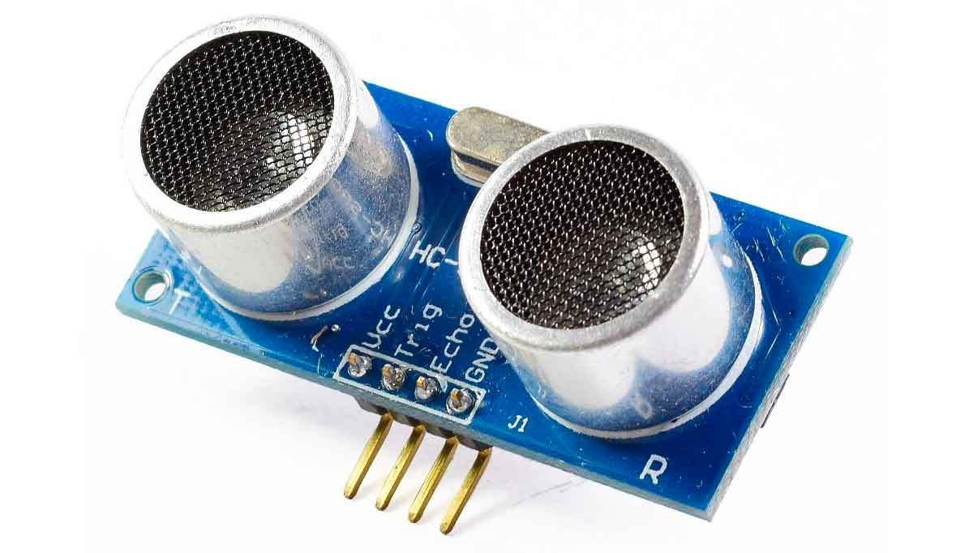

Figure 4.5 Ultrasonic Sensor

4.2.4 Camera
• Specifications:
  - Resolution: 1920 x 1080 pixels.
  - Frame Rate: 30 fps.
  - Field of View: 120 degrees.
• Functionality:
  - Captures real-time video for gesture recognition and user tracking.
• Integration:
  - Directly interfaced with the NVIDIA Jetson platform via a USB 3.0 connection to leverage high-speed data transfer.
  - Mounted on an adjustable bracket to ensure optimal viewing angle.
• Illustration:
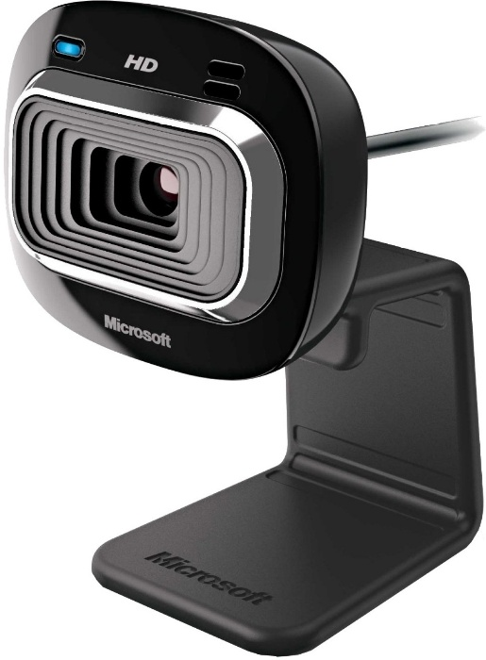
  - Figure 4.6 shows the camera used in conjunction with the Jetson Nano platform.

Figure 4.6 Camera used with Jetson Nano

4.2.5 Microcontroller (Arduino Nano)
- Specifications:
  - Processor: ATmega328P.
  - Operating Voltage: 5V.
  - Digital I/O Pins: 14.
- Role:
  - The Arduino Nano manages auxiliary functions, such as motor speed adjustments and sensor data acquisition.
- Integration:
  - Communicates with the NVIDIA Jetson platform over UART for seamless operation.
  - Powered through a dedicated 5V rail on the power distribution board to ensure stable performance.
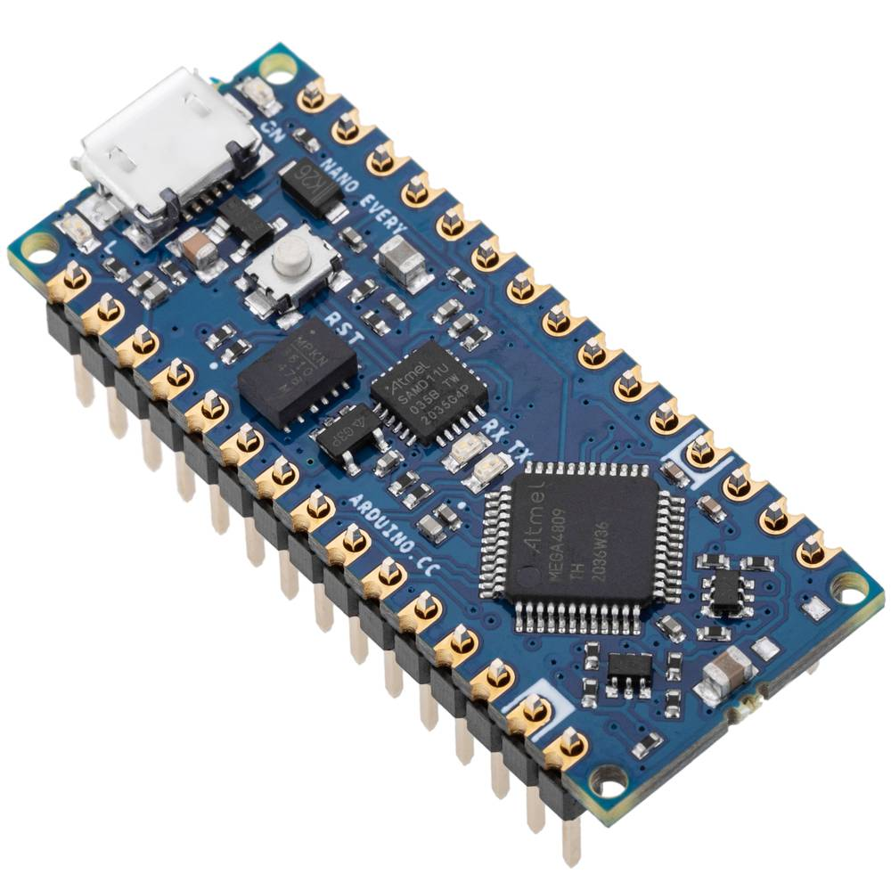
Figure 4.7 shows the Arduino Nano used in the project, illustrating its compact and versatile design.

Figure 4.7 Arduino Nano

4.2.6 NVIDIA Jetson Platform
- Specifications:
  - GPU: 128-core Maxwell architecture.
  - Memory: 4GB LPDDR4.
  - Interfaces: CSI camera, USB 3.0, GPIO.
- Functionality:
  - Processes camera input for real-time hand gesture recognition.
  - Executes AI algorithms for obstacle avoidance and user following.
- Integration:
  - Installed on a vibration-dampened mount to ensure stability during operation.
  - Paired with a cooling fan to maintain optimal operating temperatures.
Figure 4.8 illustrates the Jetson Nano used in the project, showcasing its compact yet powerful design tailored for AI and robotics applications.
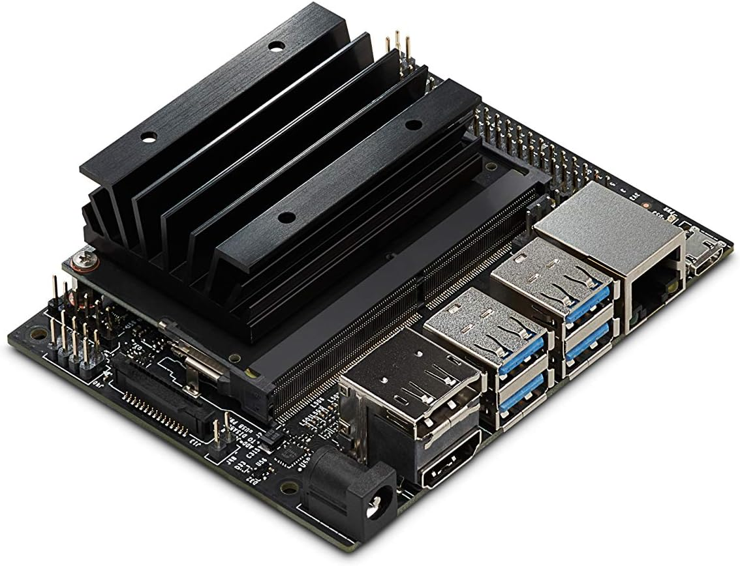

Figure 4.8 Jetson Nano

4.2.7 Battery
- Specifications:
  - Type: Lithium-ion.
  - Model: Royal Battery 12n9-bs.
  - Capacity: 12V, 32Ah.
- Power Management:
  - Provides power to the motors, microcontroller, sensors, and Jetson platform.
  - Includes a Battery Management System (BMS) for overcharge and over-discharge protection.
- Figure 4.9: Royal Battery 12N9-BS, used as the primary power source for the system.
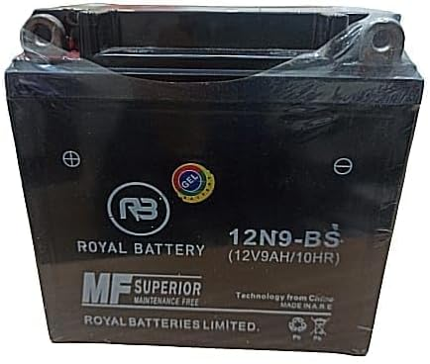
Figure 4.9 Royal Battery 12N9-BS

4.2.8 Mechanical Components
- Materials:
  - Sheet metal for the chassis to ensure durability.
  - Wood for housing electronic components, providing insulation and lightweight.
- Design Considerations:
  - The chassis was analyzed using finite element analysis (FEA) to optimize weight distribution and stress tolerance.

4.3 Integration and Implementation

4.3.1 Wiring and Assembly
- All wiring harnesses were organized using cable management channels.
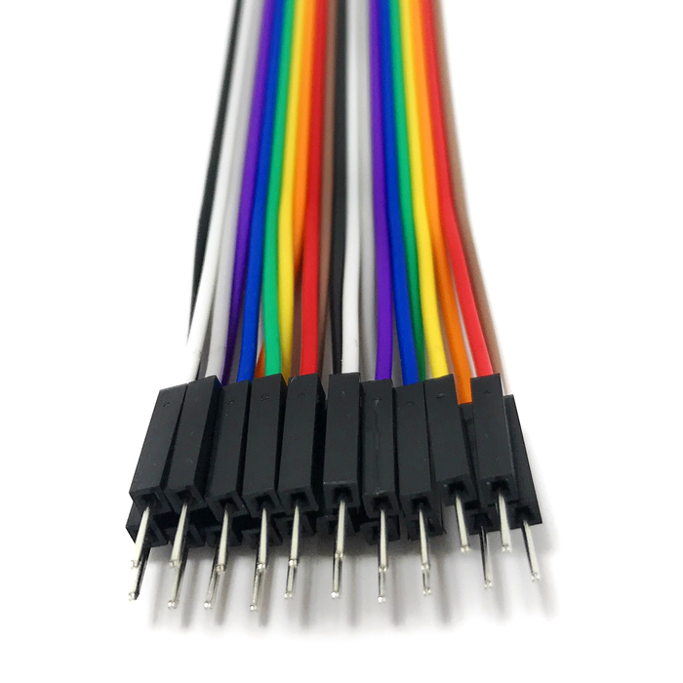
- Color-coded wires were used to simplify troubleshooting and maintenance (see Figure 4.10: Jumpers and Wires).
Figure 4.10 Jumpers

4.3.2 PCB Design and Layout
The Smart Shopping Cart relies on three custom-designed PCBs to ensure smooth functionality, safety, and user control. Each PCB serves a specific purpose within the system and has been designed with precision to minimize interference, improve reliability, and ensure ease of maintenance. This section breaks down the design, layout, and integration of each PCB, including the Motor Driver PCB, Safety PCB, and Joystick PCB.

  - Motor Driver PCB
The Motor Driver PCB is responsible for controlling the motors of the Smart Shopping Cart, acting as the interface between the microcontroller (Arduino Nano) and the motors. This board ensures that the cart’s motors operate efficiently, responding to commands such as forward movement, turning, and stopping. The motor drivers utilize Pulse Width Modulation (PWM) signals from the microcontroller, converting them into appropriate motor speed and torque adjustments.
The Motor Driver PCB features several key components designed to handle high current loads, including H-bridge circuits for motor control and built-in protection circuits to safeguard against overloads. To prevent overheating during continuous operation, the PCB includes heat sinks integrated into its layout for effective thermal management.
- Figure 4.1: Layout of the Motor Driver PCB, highlighting the components and their connections, including thermal management features such as heat sinks.
- Figure 4.3: Schematic view of the Motor Driver PCB, detailing the electrical connections for motor control and safety mechanisms.
By ensuring reliable motor control through this PCB, the Smart Shopping Cart can move accurately and respond to user commands without delay.

  - Safety PCB
The Safety PCB is designed to ensure the protection of the cart’s sensitive electronics and components from electrical issues, such as overcurrent, overheating, and short circuits. This board integrates several safety features, including overcurrent protection circuits, thermal shutdown mechanisms, and fail-safe systems that automatically disconnect power in case of a fault.
One key design feature of the Safety PCB is its fault tolerance, achieved through redundant power paths that ensure continued operation if one path fails. This redundancy helps maintain the cart’s safety in case of component failure, providing extra reliability in critical situations.
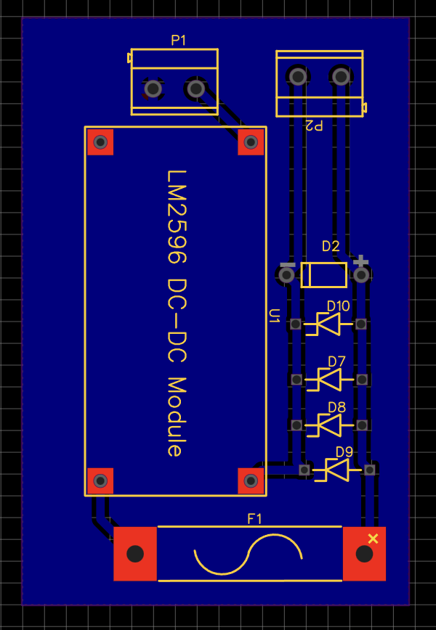
- Figure 4.11: Layout of the Safety PCB, showcasing the placement of protective components, such as current sensors and thermal protectors, as well as the redundant power paths incorporated into the design.
Figure 4.11 Safety PCB Layout

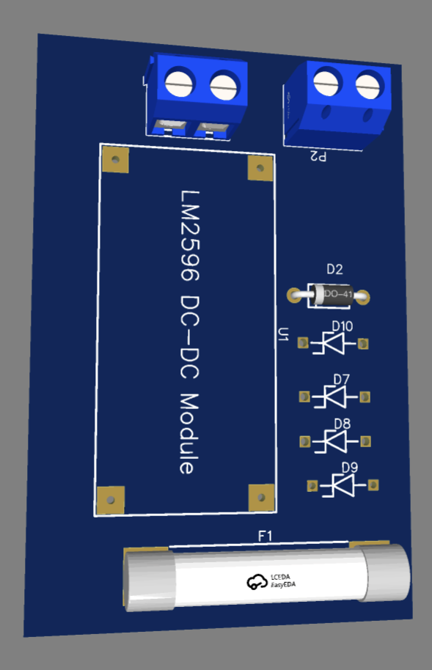
- Figure 4.12: 3D view of the Safety PCB, emphasizing its compact form factor and the strategic positioning of thermal management components. This figure highlights how the board integrates with the overall system.

Figure 4.12 3d Model for Safety PCB
- Figure 4.13: Schematic view of the Safety PCB, illustrating the electrical connections between safety features like current protection and temperature sensors. This schematic also outlines the flow of power through the redundant paths to ensure fault tolerance.
By including these safety features, the Safety PCB helps protect the cart’s components from damage and ensures the system operates reliably under varying conditions.
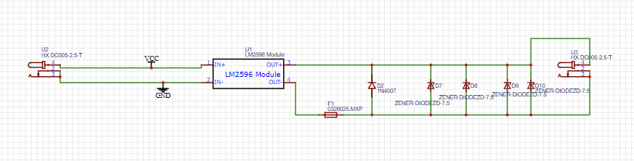
Figure 4.13 Schematic View for Safety PCB

  - Joystick PCB
The Joystick PCB is crucial for user interaction with the Smart Shopping Cart. This board translates the user's joystick movements into electrical signals, which are then interpreted by the microcontroller to control the cart’s movement. The design of the Joystick PCB focuses on low latency and high responsiveness, ensuring that user inputs are translated quickly and accurately into cart motions.
The Joystick PCB includes an analog-to-digital converter (ADC) to process the analog joystick signals into digital values that can be read by the microcontroller. Additionally, it features organized wiring and components for efficient signal routing to minimize interference and ensure smooth operation.
- Figure 4.14: Layout of the Joystick PCB, showing the organization of components such as the joystick interface and ADC converter, and highlighting how the layout contributes to the board’s responsiveness.
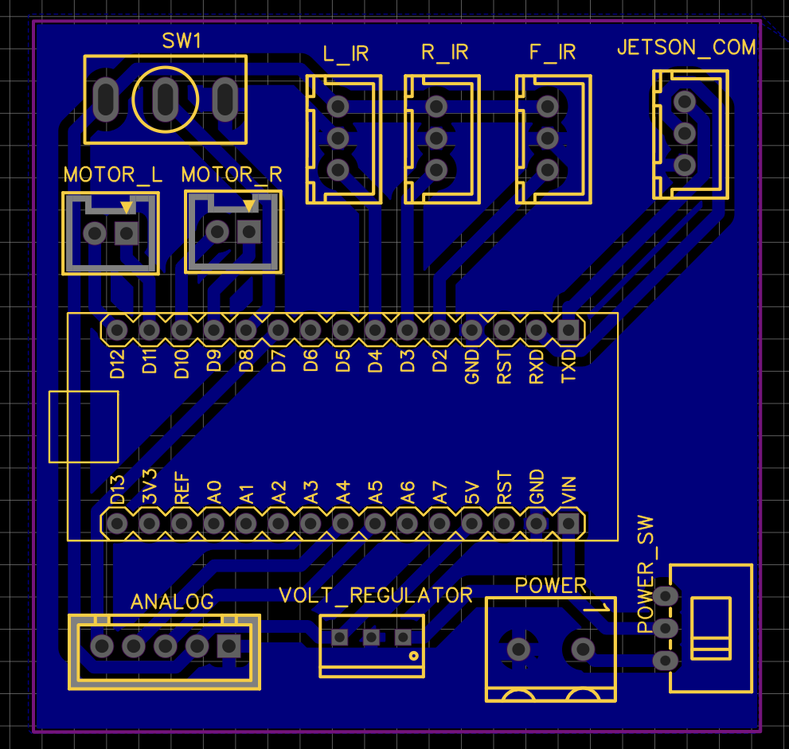
Figure 4.14 Joystick PCB Layout

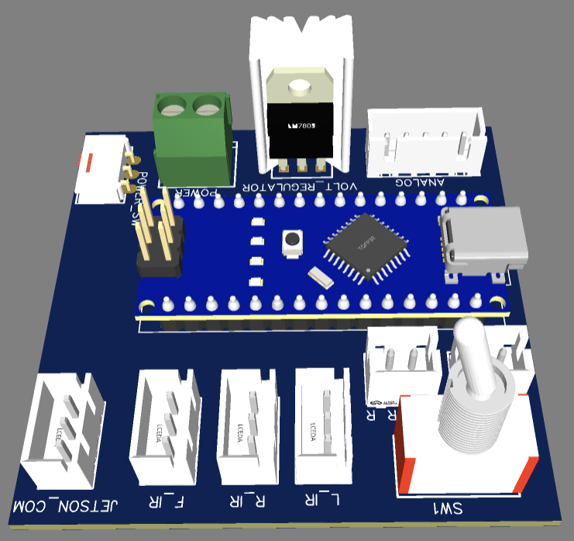
Figure 4.15: 3D view of the Joystick PCB, illustrating how the board integrates into the Smart Shopping Cart’s user interface, with attention to its compact design and functional placement.

Figure 4.15 3d Model for Joystick PCB
Figure 4.16: Schematic view of the Joystick PCB, showing the electrical pathways from the joystick to the microcontroller, including the signal processing circuit and ADC conversion process.
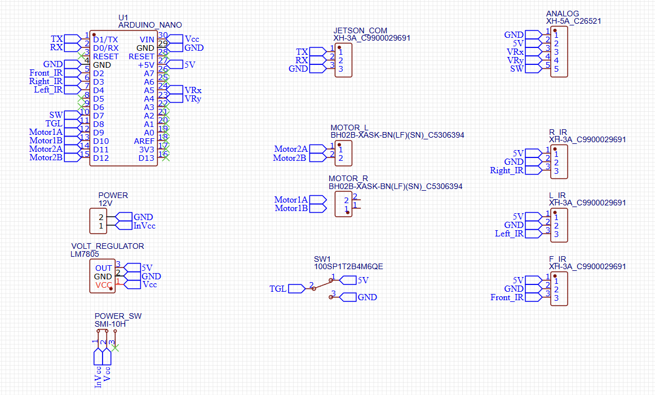
With this PCB, users can easily control the cart’s movement through intuitive joystick inputs, enhancing the cart's usability and responsiveness.

Figure 4.16 Schematic View for Joystick PCB

- PCB Design Conclusion
The three custom PCBs—Motor Driver PCB, Safety PCB, and Joystick PCB—form the backbone of the Smart Shopping Cart’s electronic system, each contributing to a specific function that enhances overall performance, safety, and user interaction. By employing these PCBs, the cart achieves reliable movement control, effective protection from electrical hazards, and seamless user input response. The integration of fault tolerance and precise layouts further boosts the cart’s robustness, ensuring it operates effectively in real-world environments.

4.3.3 Challenges and Solutions
The design and development of the Smart Shopping Cart presented several technical challenges, primarily related to the integration of electronic components and ensuring that the cart would function effectively in real-world conditions. Below are some of the key challenges encountered during the design process and the corresponding solutions that were implemented:
- Space Constraints for Mounting Electronic Components
One of the most significant challenges was the limited space available for mounting the various electronic components within the Smart Shopping Cart’s compact structure. The cart needed to accommodate several PCBs, sensors, motors, wiring, and safety features, all while maintaining an ergonomic and user-friendly design.
- Solution:
To overcome the space limitations, multi-layered mounting brackets were designed. These custom-designed brackets allow for efficient use of available space by stacking components vertically, rather than arranging them on a single plane. This solution not only maximized the use of the cart’s internal space but also ensured that each component was securely fixed in place, minimizing the risk of components shifting or becoming loose during operation. Additionally, these mounting brackets were designed to be modular, allowing for easy assembly and disassembly for maintenance or upgrades.
- Heat Management for Electronics
Another challenge involved managing the heat generated by electronic components, especially the motor drivers and power supply circuits. Continuous operation of the motors would generate significant heat, which could potentially damage sensitive components if not properly dissipated.
- Solution:
The inclusion of integrated heat sinks on the Motor Driver PCB and careful design of the Safety PCB helped manage thermal buildup. The heat sinks were strategically positioned to ensure that heat was effectively drawn away from high-temperature components, such as the motor drivers. Additionally, passive cooling methods were used to reduce the need for active cooling fans, making the cart quieter and more energy-efficient.
- Wiring and Signal Interference
Signal interference between various components, particularly in the wiring for motors and sensors, presented a significant challenge. The complexity of the system required clear and interference-free signals to ensure smooth operation, particularly for sensitive components like the sensors and joystick.
- Solution:
To combat interference, careful attention was given to the routing of wires and cables. Shielded cables were used in critical signal paths to protect them from electromagnetic interference. Furthermore, the layout of the PCB and the physical placement of wires were optimized to ensure that power lines and signal lines were kept separate as much as possible. Additionally, cable management channels were incorporated into the design to keep wiring organized, preventing tangling and reducing the risk of signal interference.

- Ensuring Structural Integrity While Reducing Weight
The design of the Smart Shopping Cart needed to balance the structural integrity of the frame with the goal of keeping the overall weight as low as possible. Excessive weight would negatively impact the cart’s movement and efficiency, while insufficient structural strength could result in failure or instability during operation.
- Solution:
To achieve this balance, lightweight yet durable materials, such as high-strength plastic composites and aluminum alloys, were chosen for the cart’s frame. The structural design was optimized using SolidWorks, employing advanced modeling techniques such as Finite Element Analysis (FEA) to identify weak points and ensure maximum strength without adding unnecessary weight. The use of multi-layered mounting brackets also helped distribute the weight evenly, preventing strain on any single component.
By addressing these challenges through thoughtful design, material selection, and engineering solutions, the development of the Smart Shopping Cart progressed smoothly, ensuring it could operate reliably and efficiently under a variety of conditions.

4.3.4 Testing and Validation
Once the design and assembly of the Smart Shopping Cart were completed, the next critical phase was testing and validation. This stage was essential to ensure that the cart performed reliably, safely, and efficiently in real-world conditions. A comprehensive set of tests was conducted to validate various aspects of the system, from motor performance to sensor reliability.

- Load Tests to Evaluate Motor Performance
To ensure that the motors used in the Smart Shopping Cart were capable of handling varying load conditions without loss of performance or overheating, a series of load tests were conducted. These tests involved simulating different payloads that the cart might carry in everyday use, ranging from light to heavy loads.
  - Test Process:
The motors were tested by gradually increasing the load they were required to move, monitoring the motor speed, torque, and temperature at each stage. Special attention was given to ensure that the motor drivers and the motors themselves remained within their operational limits under load. The PWM control signals from the Arduino Nano were adjusted to monitor how effectively the motor speed could be controlled under varying loads, ensuring smooth movement without stalling or excessive strain.
- Findings and Adjustments:
During initial testing, slight variations in motor performance were observed under heavy load conditions, particularly with regard to speed consistency. As a result, adjustments were made to the motor driver configuration, including fine-tuning the PWM signal parameters to provide more precise motor control under load. Additionally, the heat sinks on the motor driver PCB were optimized to ensure that thermal buildup did not compromise motor performance.

- Environmental Tests to Ensure Sensor Reliability
The reliability of the sensors, particularly the proximity and obstacle detection sensors, was tested under various environmental conditions. This was crucial to ensure that the cart could operate in a wide range of real-world scenarios, including different lighting conditions and varying environmental factors, such as shadows and reflections.
  - Test Process:
The sensor reliability tests involved exposing the cart to different environments, including bright sunlight, low-light conditions, and artificial lighting, to simulate real-world shopping environments. The sensor response times and accuracy were closely monitored during each test, with particular focus on how well the cart’s sensors detected obstacles in different lighting conditions. Environmental variables such as temperature and humidity were also monitored to determine if these factors had any adverse effects on sensor performance.
- Findings and Adjustments:
During the testing, it was found that certain sensors exhibited reduced accuracy under low-light conditions, particularly the infrared sensors used for obstacle detection. To address this issue, the sensor calibration algorithms were adjusted, and additional sensors were integrated to improve the cart's detection accuracy in low-light or fluctuating lighting conditions. Furthermore, the sensors’ housings were modified to reduce sensitivity to external factors, ensuring consistent performance in a variety of environments.
- Battery and Power Efficiency Tests
Another critical aspect tested was the battery life and power efficiency of the Smart Shopping Cart. Since the cart is designed for continuous movement and interaction, it was essential to ensure that the battery could support extended usage without frequent recharging.

  - Test Process:
The battery tests involved measuring the power consumption of the cart during normal operation, including during idle time and while performing different tasks such as moving and turning. The battery voltage, current draw, and overall efficiency were monitored over an extended period of time to determine the cart’s operational range.
- Findings and Adjustments:
Initial tests showed that the cart consumed more power than expected under continuous load. As a result, the power management system was refined, and the battery capacity was upgraded to ensure that the cart could operate for longer periods without a recharge. Additionally, the energy-efficient motor drivers were further optimized to reduce power loss during movement.
- User Experience and Safety Tests
Finally, user experience testing was conducted to ensure that the Smart Shopping Cart was intuitive and easy to use for shoppers, especially those with disabilities or elderly users who may require additional assistance.
  - Test Process:
A group of test users was selected to interact with the cart, providing feedback on the usability of the joystick interface, responsiveness of the motor controls, and overall ease of navigation. Special attention was paid to the safety features, such as automatic braking in case of a collision or obstacle detection failure. Feedback was gathered to refine the cart’s user interface and ensure that it met accessibility standards.
- Findings and Adjustments:
User feedback led to several key changes, including adjustments to the joystick sensitivity to improve control accuracy and the addition of extra safety features, such as automatic stopping when the cart nears obstacles. Additionally, the cart’s instructions were simplified to ensure that elderly or disabled users could quickly understand how to operate the cart.

4.4 Hardware Optimization

4.4.1 Energy Efficiency
- Sleep Modes:
  - The Arduino Nano and Jetson platform were programmed to enter low-power sleep modes during idle periods, reducing energy consumption.
  - Sensors and peripherals were also put into standby mode when not actively used, ensuring minimal power draw.
- Power Regulation:
  - A high-efficiency DC-DC converter was utilized to regulate power distribution and minimize energy loss.
  - Separate voltage rails were implemented to optimize power delivery to components, reducing unnecessary energy waste.
- Battery Monitoring:
  - Integrated a real-time battery monitoring system to track power usage and provide early warnings for low battery levels, enabling better energy management.
  - The Battery Management System (BMS) also ensures optimized charging cycles, prolonging the battery lifespan.
- Energy-Efficient Algorithms:
  - Computational tasks on the Jetson platform were optimized by employing lightweight YOLO models (e.g., YOLOv8 Nano) and Mediapipe modules, reducing the system's overall power requirements.

4.4.2 Durability Enhancements
- Structural Reinforcement:
  - Critical joints were reinforced with high-strength bolts, reducing the risk of failure under load or vibration.
  - Welds were inspected and tested for uniformity to ensure structural integrity during operation.
- Protective Covering:
  - A protective acrylic enclosure was installed over the electronics to safeguard against dust, moisture, and accidental impacts.
  - The acrylic cover included ventilation slots to prevent overheating while maintaining protection.
- Cable Management:
  - All wiring harnesses were organized using cable management channels to prevent tangling and ensure ease of maintenance.
  - Heat-resistant cable sleeves were added to protect wires from potential thermal damage near the motors and power components.
- Vibration Dampening:
  - Rubber mounts and vibration-dampening materials were used under the motor mounts and the Jetson Nano platform, reducing the impact of vibrations on sensitive components.
- Environmental Protection:
  - Components were treated with corrosion-resistant coatings to enhance durability in humid or dusty environments.
  - The motor drivers and PCBs were coated with a conformal layer to protect against moisture and potential short circuits.

4.4.3 Thermal Management
- Cooling System:
  - A high-speed cooling fan was installed on the Jetson Nano, and heatsinks were added to the motor drivers to ensure components operate within optimal temperature ranges.
  - Airflow pathways were designed for maximum cooling efficiency, preventing thermal throttling during prolonged use.
- Thermal Sensors:
  - Temperature sensors were integrated near critical components to monitor real-time thermal conditions.
  - The system was programmed to trigger a safe shutdown or reduce processing loads in case of overheating.

4.4.4 Maintenance Considerations
- Modular Design:
  - Components were mounted on modular brackets, allowing for quick replacement or upgrades without requiring extensive disassembly.
  - A detailed wiring diagram and component map were created for troubleshooting and repairs.
- Service Indicators:
  - LEDs were installed to indicate system health, including power status, connectivity, and errors, simplifying diagnostics.

4.5 Challenges and Lessons Learned

4.5.1 Key Difficulties
- Subsystem Integration:
  - Maintaining seamless communication between multiple subsystems (Jetson Nano, Arduino Nano, sensors, and motor drivers) posed significant challenges.
  - Differences in communication protocols (UART, PWM, and GPIO) required meticulous configuration and debugging to ensure compatibility and reliability.
  - Synchronizing real-time data processing, such as hand gesture recognition and obstacle detection, demanded rigorous testing to eliminate latency and data loss.
- Thermal Management:
  - Ensuring efficient heat dissipation for high-power components like the Jetson Nano and motor drivers within a compact design was particularly challenging.
  - Limited space for airflow and the need for additional components (e.g., cooling fans and heatsinks) required iterative redesigns to achieve optimal thermal management without compromising system performance.
- Power Consumption:
  - Balancing the power requirements of high-performance components with the battery’s capacity was a critical issue.
  - Achieving energy efficiency without sacrificing functionality, particularly during prolonged operations, involved extensive testing and optimization of hardware and software.
- Obstacle Detection and Avoidance:
  - Ensuring accurate obstacle detection using IR and ultrasonic sensors proved difficult in varying environmental conditions such as bright lighting, reflective surfaces, and cluttered spaces.
  - Fine-tuning sensor thresholds and implementing robust signal filtering algorithms required several iterations.

- Mechanical Durability:
  - Designing a structure capable of withstanding vibrations and impacts during operation while maintaining lightweight construction was a significant challenge.
  - Material selection and joint reinforcement required careful consideration to achieve both durability and mobility.
- Prototyping and Testing:
  - Initial prototypes revealed unforeseen issues, such as wiring failures, inconsistent sensor readings, and poor mounting stability, necessitating frequent redesigns.
  - Debugging software and hardware simultaneously while integrating new features was time-consuming and required effective team coordination.

4.5.2 Lessons Learned
- Importance of Modular Design:
  - Adopting a modular approach in hardware and software development simplified iterative improvements and troubleshooting.
  - Modular components allowed for easy replacement, upgrades, and debugging, reducing downtime during testing phases.
- Value of Early Prototyping:
  - Early prototyping highlighted potential integration issues, such as signal interference and structural weaknesses, enabling the team to address these challenges before final implementation.
  - Prototypes also provided valuable insights into user interaction and system performance, guiding subsequent design improvements.

- Thorough Testing Is Crucial:
  - Rigorous testing under different environmental conditions (e.g., lighting, terrain, and obstacle configurations) was essential to identify and mitigate edge cases that could compromise system reliability.
  - Testing also helped refine calibration parameters for sensors and motors, improving overall system accuracy and responsiveness.
- Team Coordination and Communication:
  - Effective collaboration between team members across various domains (mechanical, electrical, and software) was critical in overcoming integration challenges.
  - Regular meetings and documentation ensured that all team members were aligned on project goals and progress.
- Flexibility in Problem-Solving:
  - Encountering unexpected issues required the team to adopt creative solutions, such as using alternative materials, redesigning components, or refining software algorithms.
  - Learning to adapt quickly to changing requirements and constraints was a valuable skill gained during the project.
- Energy Efficiency as a Priority:
  - Balancing performance and energy consumption required significant effort but emphasized the importance of optimizing algorithms and power management systems.
  - This experience underscored the need to consider energy efficiency from the initial stages of design.
- Documentation and Planning:
  - Maintaining detailed documentation throughout the project streamlined troubleshooting and ensured continuity when handing over tasks between team members.
  - Proper planning and task allocation helped prevent delays and ensured efficient use of available resources.

Conclusion
The hardware implementation of the Automated Follow-Me Cart was a meticulously designed and integrated system that brought together mechanical durability, electronic precision, and energy efficiency to meet the needs of its intended users. The careful selection of components such as the NVIDIA Jetson Nano, Arduino Nano, IR and ultrasonic sensors, and robust motor drivers ensured seamless communication and reliable performance. Through extensive testing and optimization, the team achieved a design that balances functionality, scalability, and energy conservation.
The integration of a modular approach allowed for adaptability, while the emphasis on durability and efficient power management enhanced the system's long-term reliability. Each component, from the reinforced mechanical structure to the advanced computing and sensing systems, worked cohesively to deliver a practical solution for assisting elderly and disabled individuals. This hardware foundation not only fulfilled the project objectives but also paved the way for future enhancements, underscoring the importance of innovation, teamwork, and iterative design in engineering complex systems.

Chapter 5
Software Integration

5. Software Integration

5.1 Software and System Integration Introduction
In today’s fast-paced world, automation and convenience are transforming the retail experience. This project introduces a Smart Shopping Cart that integrates advanced computer vision and machine learning technologies to enhance customer convenience. This document delves into the software architecture and system design that make the project feasible, focusing on the integration of Jetson Nano, ATmega328P, and various sensors.

5.2 Why Smart Shopping Cart
The concept of a Smart Shopping Cart addresses several critical challenges in modern retail and offers significant benefits across various domains:
  - Enhancing Customer Convenience
- Time Efficiency: Customers no longer need to manually push carts or stand in long queues. The cart tracks them and automates checkout, streamlining the shopping experience.
- Accessibility: Assists individuals with mobility challenges by offering automated navigation and gesture-based controls.
  - Retail Innovation
- Competitive Edge: Retailers adopting smart carts can differentiate themselves in a crowded market, attracting tech-savvy customers.
- Data-Driven Insights: The system can collect anonymous shopping patterns to help businesses optimize inventory and layout.

  - Integration with Smart Ecosystems
- Seamless Technology: Combines IoT, machine learning, and automation to fit into a future of interconnected smart devices.
- Scalability: Can evolve to incorporate additional features like personalized promotions, voice recognition, and payment integration.
  - Addressing Labor Shortages
- Automated solutions like the Smart Shopping Cart can reduce the dependency on staff for tasks like stocking assistance or customer support, addressing labor gaps without compromising service quality.

5.3 System Overview
The Smart Shopping Cart incorporates several key components that enable its advanced functionality and autonomous behavior. Each component plays a crucial role in ensuring the cart operates efficiently, providing an enhanced shopping experience for users.
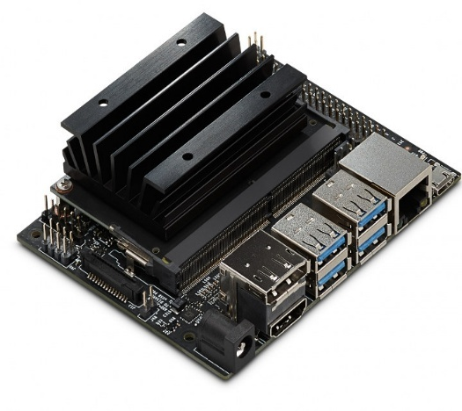
- Jetson Nano (Showed in Figure 5.1): The Jetson Nano is the central processing unit responsible for advanced machine learning tasks such as object detection and tracking. It is equipped with a powerful GPU that enables real-time image processing, making it possible for the cart to follow customers autonomously and respond to various environmental changes. With its compact form and high performance, the Jetson Nano is an ideal choice for deploying AI algorithms in embedded systems like our Smart Shopping Cart.

Figure 5.1 Jetson Nano
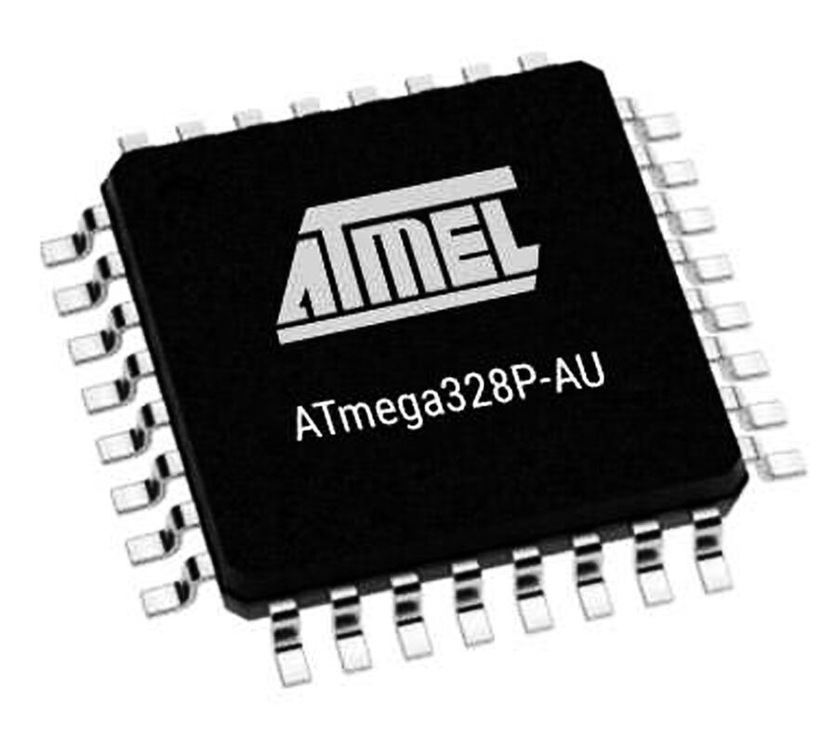
- ATmega328P (Showed in Figure 3.2): The ATmega328P is used as the microcontroller for real-time control and decision-making. It handles tasks such as managing communication between the sensors and motors, processing inputs from the user, and facilitating smooth transitions between autonomous and manual control modes. The ATmega328P’s simplicity and low power consumption make it a reliable and efficient choice for ensuring that the cart responds quickly and effectively to user commands.

Figure 5.2 ATmega328P

- Camera (Showed in Figure 5.3): The camera mounted on the Smart Shopping Cart is essential for vision-based tasks, including object detection and customer tracking. It works in tandem with Jetson Nano to process and analyze visual data, enabling the cart to identify the customer, follow them, and avoid obstacles. The camera captures a wide field of view, allowing for accurate and real-time processing, which is crucial for the cart’s autonomous navigation in a busy retail environment.
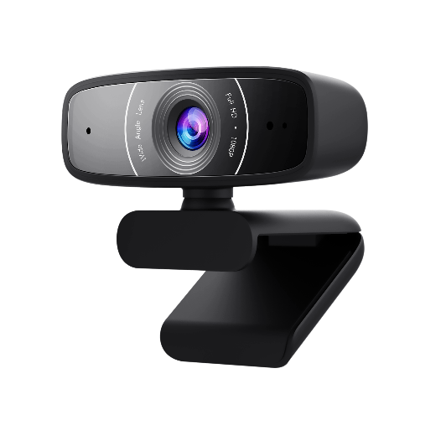

Figure 5.3 Camera used with Jetson Nano
- IR Sensor (Figure 5.4): The IR sensor is used for proximity detection, allowing the Smart Shopping Cart to detect obstacles and avoid collisions. Positioned around the cart, these sensors help maintain safe distances from objects and people, ensuring the cart navigates smoothly without causing disruptions. The IR sensor also aids in detecting the cart’s surroundings, allowing for enhanced navigation and control in crowded or dynamic environments.
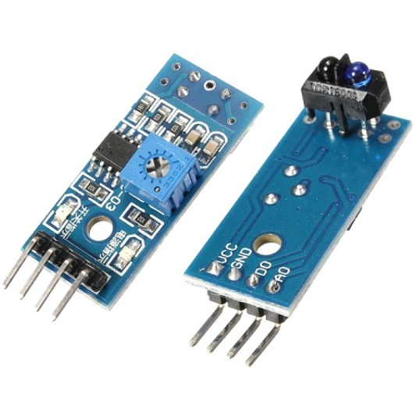
Figure 5.4 IR Sensor Both Ways

Together, these components work in harmony to create a seamless and intuitive shopping experience, combining machine learning, real-time processing, and effective sensing capabilities to deliver an intelligent and user-friendly Smart Shopping Cart system.

5.4 Software Background

5.4.1 Artificial Intelligence (AI)
AI refers to the development of systems capable of performing tasks that typically require human intelligence. These tasks include problem-solving, decision-making, and language understanding. AI systems can be broadly categorized into:
  - Narrow AI: Systems specialized for specific tasks, like recommendation algorithms.
  - General AI: Hypothetical systems with capabilities equal to human cognitive abilities.

5.4.2 Machine Learning (ML)
ML is a subset of AI focused on enabling machines to learn from data without explicit programming. The primary types of ML include:
  - Supervised Learning: Models learn from labeled data (e.g., predicting house prices).
  - Unsupervised Learning: Models identify patterns in unlabeled data (e.g., clustering customer segments).
  - Reinforcement Learning: Models learn by interacting with an environment to maximize rewards (e.g., game-playing agents).

5.4.3 Deep Learning (DL)
DL is a specialized branch of ML that utilizes artificial neural networks to mimic the structure and function of the human brain. Key characteristics include:
- Multi-Layered Networks: Deep architectures with multiple layers extract hierarchical features from data.
- High Computational Power: Requires GPUs or specialized hardware for training complex models.
- Applications: Image recognition, speech synthesis, and autonomous vehicles.

5.4.4 Computer Vision
Computer Vision enables machines to interpret and analyze visual data. It encompasses tasks such as:
- Object Detection: Identifying objects in images or videos (e.g., YOLO).
- Image Segmentation: Dividing an image into meaningful regions.
- Facial Recognition: Identifying individuals based on facial features.

5.4.5 Convolutional Neural Networks (CNNs)
- Convolution Operation
  - Extracts features by sliding a kernel over the input image.
  - Captures local patterns such as edges or textures.
- Pooling Layer
  - Reduces the spatial dimensions of the feature maps.
  - Common pooling types include max pooling and average pooling.
- Activation Function
  - Introduces non-linearity to the model, enabling it to learn complex patterns.
  - Common functions: ReLU, Sigmoid, Tanh.
- Fully Connected Layer
  - Connects all neurons in one layer to those in the next.
  - Combines features extracted by previous layers for final predictions.
- Dropout Layer
  - Prevents overfitting by randomly disabling a fraction of neurons during training.
  - Enhances generalization by reducing reliance on specific neurons.

5.5 YOLO

5.5.1 Introduction to YOLO
YOLO (You Only Look Once) is a groundbreaking real-time object detection algorithm that has set a benchmark in computer vision applications. Unlike traditional methods that scan through images using region-based proposals or sliding windows, YOLO examines the entire image in a single computational step. This approach ensures both speed and accuracy, making it particularly valuable for time-critical applications such as autonomous driving, surveillance, and robotics.
Figure 5.5 illustrates the logo of YOLO v8, representing the latest advancements in this algorithm's development.

Figure 5.5 YOLO V8 Logo

5.5.2 Key Features of YOLO
- Real-Time Performance: YOLO’s architecture processes images in milliseconds, making it ideal for real-time detection tasks. Its speed allows deployment in applications where high frame rates are crucial.
- Unified Architecture: The algorithm divides the input image into an S×S grid. Each grid cell predicts bounding boxes, confidence scores, and class probabilities concurrently, eliminating the need for multiple stages.
- Multi-Object Detection: YOLO can accurately detect and classify multiple objects within an image, regardless of their size or positions. This feature is vital for analyzing dynamic and complex scenes.
- Generalization Capability: YOLO demonstrates exceptional generalization on unseen data, allowing it to work effectively across diverse datasets and use cases.
- Scalability and Optimization: The introduction of YOLO v8 brings enhancements in performance, scalability, and integration with various platforms, making it easier to deploy on embedded systems or cloud environments.

5.5.3 How YOLO Works
- Image Input: YOLO begins by taking an input image and dividing it into an S×S grid (e.g., 7×7 for smaller models). Each cell is responsible for detecting objects whose center lies within the cell.
- Bounding Box Predictions: Each grid cell predicts a fixed number of bounding boxes, along with their confidence scores. These scores reflect the likelihood that a bounding box contains an object and the accuracy of its location.
- Class Prediction: For each bounding box, YOLO predicts class probabilities. These probabilities indicate the likelihood of the detected object belonging to specific categories, such as "person," "vehicle," or "item."
- Non-Max Suppression: To refine the results, YOLO employs Non-Max Suppression (NMS). This step removes redundant bounding boxes by retaining only the ones with the highest confidence scores for each detected object.
- End-to-End Training: YOLO is trained as a single neural network, optimizing for both classification and localization tasks. This unified training approach simplifies implementation and improves overall efficiency.
Figure 5.6 demonstrates YOLO's object detection capabilities, showing how the algorithm identifies objects within a scene and highlights them with bounding boxes.
Figure 5.7 illustrates YOLO's object classification, depicting how it assigns class labels to detected objects and displays their respective probabilities.
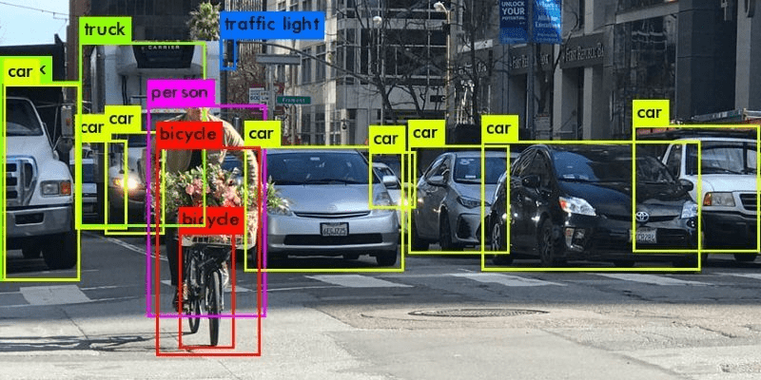
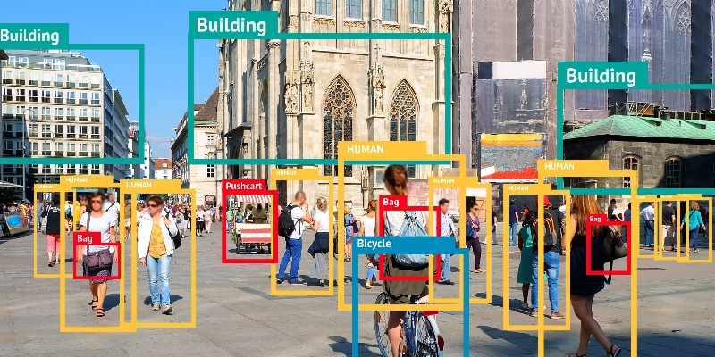
These features and processes enable YOLO to stand out as one of the most efficient and versatile object detection algorithms available, setting the stage for its integration into a wide range of innovative applications.
Figure 5.7 Object detection and classification ex1
Figure 5.6 Object detection and classification ex1

5.5.4 Using YOLO in the Smart Shopping Cart Project
In the Smart Shopping Cart project, YOLO plays a crucial role in delivering intelligent functionality by leveraging its real-time object detection and tracking capabilities. It was customized and optimized to perform specific tasks relevant to enhancing the shopping experience. Below are the key applications and enhancements:
- Customer Tracking
- Detecting and Identifying Customers: YOLO was used to detect customers based on their appearance, such as facial features, clothing patterns, and overall posture. This feature enables the cart to establish a "lock" on the designated shopper.
- Reliable Following Mechanism: Even in crowded retail environments, YOLO ensures that the cart can distinguish the customer from other shoppers by consistently analyzing spatial and temporal cues.
- Dynamic Adaptability: The algorithm adapts to changes in the customer's position, orientation, and distance by continuously updating bounding boxes. This ensures smooth tracking, even when the customer moves quickly or changes direction.
Example: Figure 5.6 demonstrates how YOLO identifies and tracks a specific individual in a crowded setting using bounding boxes and confidence scores.
- Object Recognition
- Obstacle Detection and Navigation: YOLO is integrated with the cart’s navigation system to recognize obstacles like shelves, other carts, or stationary objects in real time. This information is used to make instant course corrections, ensuring safe and efficient movement.
- Product Detection: The algorithm identifies products in the customer’s vicinity, enabling future possibilities like real-time scanning for product information or assisting customers in locating specific items.
- Zone Awareness: YOLO helps the cart understand its surroundings, such as recognizing store aisles or checkout counters, adding an intelligent spatial-awareness component to the system.
Example: Figure 5.7 highlights YOLO’s capability to recognize and classify various objects within a shopping environment, such as products, aisles, and obstacles.
- Customization for Retail Environments
- Custom Dataset Creation:
  - The team collected a dataset tailored for retail, comprising thousands of images featuring customers in different poses, store layouts, and environmental conditions.
  - The images were meticulously labeled with bounding boxes and object classes to train YOLO effectively.
- Augmentation Techniques: To improve robustness, various augmentation techniques were employed, such as:
  - Brightness and contrast adjustments for varying lighting.
  - Perspective distortions to simulate different camera angles.
  - Noise addition to improve resilience to real-world imperfections.
- Fine-Tuning the Model: The pre-trained YOLO model was fine-tuned on this custom dataset to adapt it specifically for the Smart Shopping Cart’s use case. This enhanced its accuracy in detecting both customers and retail-specific objects.
- Performance Optimization
- Lightweight YOLO Models:
  - To achieve real-time performance, YOLOv8’s lightweight versions (e.g., YOLOv8 Nano or YOLOv8 Small) were deployed on the Jetson Nano. These models balance accuracy and computational efficiency, ensuring smooth operation.
- Model Quantization: Techniques like quantization were applied to reduce model size and inference time while maintaining acceptable accuracy levels.
- Hardware Acceleration: The Jetson Nano’s GPU was leveraged for accelerated computations, enabling YOLO to process high-resolution images at competitive frame rates.
- Energy Efficiency: Optimizing YOLO for the Jetson Nano not only ensured faster detection but also minimized energy consumption, making the system more sustainable for prolonged use.
- Real-World Testing
The customized YOLO system was rigorously tested in simulated and real-world shopping environments, focusing on:
- Accuracy: Measuring the precision and recall in detecting customers and obstacles.
- Speed: Ensuring real-time object detection and response, with latency kept under 50 milliseconds.
- Reliability: Evaluating YOLO’s performance in diverse conditions, such as crowded stores, varying lighting, and different customer behaviors.
Through these integrations and optimizations, YOLO has become a cornerstone of the Smart Shopping Cart’s functionality, enabling a seamless, efficient, and intelligent shopping experience.

5.6 Mediapipe
Mediapipe is an open-source framework developed by Google that has gained recognition for its efficiency and flexibility in building machine learning (ML) pipelines for real-time perception tasks. It enables developers to deploy robust, cross-platform solutions for a variety of computer vision applications, such as hand tracking, facial detection, pose estimation, and object detection. Mediapipe's modularity and performance make it a key tool for ML-based applications, particularly those running on edge devices.

5.6.1 Mediapipe Application in the Project
In the Smart Shopping Cart project, Mediapipe was employed to enhance human-computer interaction by providing an intuitive and efficient way to recognize hand gestures and interact with the cart. By leveraging its robust hand tracking and landmark detection capabilities, Mediapipe plays an integral role in gesture recognition for controlling the cart's movement and other functions.
Figure 5.8 illustrates the Mediapipe logo, highlighting its brand and association with cutting-edge perception technologies.


Figure 5.8 Mediapipe logo

- Key Features of Mediapipe
  - Cross-Platform Support: Mediapipe works seamlessly across various platforms, including Android, iOS, desktop, and web browsers. This makes it ideal for edge devices like Jetson Nano, ensuring portability and scalability.
  - High Performance: Mediapipe is optimized for real-time processing, enabling applications to analyze video streams and perform accurate landmark detection with minimal latency.
  - Pre-Built Solutions: Mediapipe provides ready-to-use modules for tasks like Hand Tracking, Face Mesh, Pose Estimation, and Objectron (3D object detection).
  - Efficient GPU Utilization: Mediapipe leverages hardware acceleration when available, allowing it to process complex tasks, such as hand gesture detection, at high frame rates on devices with constrained resources.
  - Easy Integration: With its modular graph-based design, Mediapipe allows developers to combine different modules and customize pipelines to suit specific use cases.

- Mediapipe’s Role in the Smart Shopping Cart
- Hand Gesture Recognition:
  - The Hand Tracking module of Mediapipe was employed to detect and track the user's hand in real time.
  - Mediapipe identifies 21 landmark points on the hand (Figure 5.9), which are used to interpret gestures, such as signaling the cart to stop, follow, or change direction.
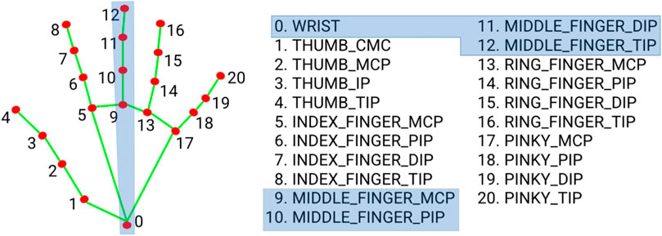
  - This functionality provides an intuitive interface, eliminating the need for physical controls and making the cart more accessible for elderly and disabled users.

Figure 5.9 Hand landmark points
- Gesture Customization:
  - Custom gestures were defined and programmed into the system to align with user-friendly commands. For example, a specific hand pose could signal the cart to follow the user or halt.
  - The use of Mediapipe’s pose estimation pipeline ensures that gestures are recognized accurately even in varied lighting or environmental conditions.
- Efficiency on Edge Devices:
  - Mediapipe’s computational efficiency enables the real-time tracking of hands and gestures on the Jetson Nano.
  - The framework processes live video input from the camera while maintaining low latency, which is crucial for ensuring seamless interactions.
- Robustness in Diverse Conditions:
  - Mediapipe's multi-hand tracking feature is used to handle scenarios where multiple users are interacting with the cart, ensuring that only the designated user’s gestures are interpreted.
  - Through optimization and augmentation, Mediapipe maintained its performance in conditions such as poor lighting, occlusions, and high-motion environments.
- Integration with Other Modules:
  - Mediapipe outputs were combined with the YOLO module to enhance the cart's decision-making. For example, while Mediapipe tracks gestures, YOLO ensures spatial awareness by detecting obstacles.

Training and Optimization
- Custom Dataset: Additional training was conducted using a dataset of gesture videos collected in diverse shopping environments.
- Preprocessing Pipelines: Frames from video streams were preprocessed using Mediapipe’s built-in modules to detect and extract key features for gesture analysis.
- Hardware Optimization: Mediapipe’s graphs were tailored to minimize resource usage on the Jetson Nano, allowing for the smooth coexistence of other intensive tasks like YOLO.

5.6.2 How We Used Mediapipe in the Project
In the Smart Shopping Cart project, Mediapipe played a crucial role in enabling intuitive and hands-free control of the cart through advanced gesture recognition. Its implementation was tailored to enhance the interaction between the user and the cart, ensuring an efficient and seamless shopping experience.

Applications of Mediapipe in the Project

Hand Gesture Recognition
- Hand Tracking Solution:
  - Mediapipe’s Hand Tracking module was utilized to detect and analyze the user’s hand movements in real-time.
  - By identifying 21 key landmark points on the hand, Mediapipe allowed the system to interpret specific gestures accurately.
  - These gestures were mapped to commands for the cart, such as:
    - Follow Me Signal: A predefined gesture, such as an open hand, signaled the cart to begin following the user (Figure 3.10).
    - Stop Signal: A closed fist or another predefined gesture prompted the cart to stop (Figure 3.11).

Figure 5.10 Follow Me Signaling from Hand Gestures

Figure 5.11 Stop Signaling from Hand Gestures

- Dynamic Environment Adaptation:
  - Mediapipe’s robust tracking capabilities ensured that gestures were detected reliably, even in crowded or complex retail environments.
  - It handled occlusions effectively, maintaining accuracy when the hand was partially obscured or in motion.

Real-Time Interaction
- The Mediapipe framework enabled low-latency gesture recognition, allowing the cart to respond almost instantly to user commands.
- The high-speed detection was crucial for creating a responsive system that felt natural to users.

Efficiency on Edge Devices
- Lightweight Design:
  - Mediapipe’s computational efficiency ensured that the Jetson Nano, a resource-constrained edge device, could handle gesture recognition alongside other tasks like object detection (via YOLO).
- Optimized Graphs:
  - The pre-built Mediapipe graphs were optimized to reduce memory usage and processing overhead, ensuring the smooth operation of the entire system.
- Real-Time Performance:
  - Despite the Jetson Nano's hardware limitations, Mediapipe delivered high frame rates, enabling gestures to be recognized without delays.

Gesture-Based Control
- The use of Mediapipe eliminated the need for physical buttons or controls, providing a hands-free interaction method that was especially beneficial for elderly and disabled users.
- Custom gesture commands were designed to ensure simplicity and reliability:
  - Follow Me Gesture (Figure 5.10): This gesture signaled the cart to align itself with the user and start following their movements.
  - Stop Gesture (Figure 5.11): A specific gesture instructed the cart to halt its movement immediately, ensuring safety and control.

Integration and Customization
- Dataset Customization:
  - A custom dataset of gesture images and videos was collected and labeled to fine-tune the Mediapipe module for the retail environment.
- Noise Handling:
  - Additional filtering techniques were implemented to prevent false positives or misinterpretations in busy environments, ensuring robust performance.
- Multi-User Scenarios:
  - The system was trained to prioritize gestures from the designated user, ignoring inputs from others in the vicinity.

Impact on the Project
By incorporating Mediapipe, the Smart Shopping Cart achieved a highly responsive and user-friendly gesture control system. This not only improved the overall user experience but also enhanced the cart's accessibility and functionality, aligning with the project's goal of assisting disabled and elderly individuals.
- Figure 5.10: A visual demonstration of the Follow Me gesture, showing how the cart responds to the user’s command by initiating the follow mode.
- Figure 5.11: A depiction of the Stop gesture, illustrating the cart halting its movement in response to the user’s signal.
The seamless integration of Mediapipe with the Jetson Nano and other modules ensures that the Smart Shopping Cart remains efficient, intuitive, and reliable in diverse real-world scenarios.

5.7 Computer Vision usage in the project

5.7.1 Developing an Accurate Hand Gesture System and Clothing Detection with YOLO
The goal of the hand gesture recognition system is to enable intuitive and accurate interaction between the customer and the cart. The development process involves:
- Identifying Requirements:
  - Determine the gestures to be recognized (e.g., open hand, fist, pointing).
  - Define the interaction use cases, such as starting, stopping, or turning the cart.
- Choosing the Framework:
  - Mediapipe is selected for its robust real-time hand tracking capabilities, capable of detecting 21 landmarks on the hand.
- Data Collection and Annotation
  - Gather sample hand gestures in various lighting and environmental conditions.
  - Annotate the data for training and testing to ensure accurate recognition.
- Gesture Classification:
  - Develop a model to classify gestures based on the relative positions of hand landmarks.
  - Use labeled data to train the model, optimizing for speed and accuracy.
- Integration with Cart Control:
  - The map recognized gestures to specific cart functions.
  - Test and refine the system to ensure smooth user interactions.

5.7.2 Clothing Detection with YOLO Development Process
The objective is to identify customer clothing items in real time to provide personalized shopping experiences. The steps include:
- Defining Objectives:
  - Identify categories of clothing to be detected, such as shirts, pants, dresses, and jackets.
  - Determine how the detection results will be used, such as suggesting complementary items.
- Dataset Preparation:
  - Collect images representing various clothing types and styles.
  - Label the data to indicate the location and category of each clothing item.
- Model Selection:
  - YOLO (You Only Look Once) is chosen for its speed and accuracy in object detection.
  - A pretrained YOLO model is fine-tuned with the custom dataset.

5.7.3 System Integration Process
To create a cohesive and functional smart shopping cart system, integrating the various components—hand gesture recognition, clothing detection, and cart control—was crucial. The integration process involved:
- Defining the Integration Framework:
  - Established a unified architecture to connect gesture recognition, object detection, and cart operations.
  - Selected a robust communication protocol for real-time data exchange between components.
- Interfacing the Gesture Recognition System:
  - Connected the hand gesture recognition module to the cart’s control unit.
  - Mapped gesture outputs (e.g., stopping, moving, turning) to specific commands that the cart's motor control system could execute.
- Integrating Clothing Detection:
  - Incorporated the YOLO-based clothing detection system into the visual processing unit.
  - Ensured detection results could trigger relevant shopping suggestions displayed on a screen or sent to the user's mobile device
- Real-Time Data Processing:
  - Implemented a pipeline to process gesture and clothing data concurrently without delays.
  - Used multithreading to handle input from multiple sensors (camera, accelerometer) efficiently.
- Central Control and Decision-Making:
  - Designed a central control module to prioritize and synchronize inputs from gesture and clothing detection systems.
  - Enabled the cart to make autonomous decisions based on combined inputs, such as stopping when detecting an obstacle or displaying recommendations for identified clothing.

5.7.4 Testing and Refinement
- Conducted iterative testing in simulated and real-world environments to identify and address bottlenecks.
- Improved system responsiveness and accuracy based on user feedback and error logs.

5.8 Setting up HW (Jetson nano)

5.8.1 Initializing the Jetson Nano
The Jetson Nano serves as the primary processing unit in the Smart Shopping Cart, handling computationally intensive tasks such as object detection and hand gesture recognition. To ensure optimal performance, the initialization process involved several key steps, setting up both the hardware and software environments.

Steps for Initializing the Jetson Nano

1. Creating a New Image
- Downloading the Official Jetson Nano Image:
  - The Jetson Nano Developer Kit image was obtained from the NVIDIA Developer Website, ensuring compatibility and access to the latest updates.
  - The image included pre-installed libraries and drivers optimized for the Nano’s GPU, such as CUDA, cuDNN, and TensorRT, which are essential for running machine learning models.
- Flashing the Image:
  - The downloaded image was written to a high-speed SD card (minimum Class 10) using tools like Balena Etcher.
  - This ensured that the system could boot efficiently and handle the required read/write operations during real-time processing.

2. Initial Setup
- Booting the Jetson Nano:
  - After inserting the flashed SD card, the Nano was powered on. The initial boot sequence loaded the operating system and prompted the user for setup.
- Network Configuration:
  - A stable network connection was established via Ethernet or Wi-Fi using a compatible USB adapter. This was critical for downloading additional software packages and updates.
- User Credentials and System Updates:
  - A unique username and password were configured for secure access.
  - The system was updated using the command sudo apt update && sudo apt upgrade to ensure all packages were up-to-date.

3. Jetson Nano Interface
- Upon completion of the initial setup, the Jetson Nano desktop interface was displayed (Figure 5.12).
  - The interface provided access to pre-installed tools such as the Jetson SDK Manager, NVIDIA Developer Tools, and the Linux terminal.
  - Key features included:
    - A simple interface for managing installed applications and system resources.
    - Direct access to the JetPack SDK, which includes libraries and frameworks like OpenCV and DeepStream for AI and computer vision tasks.

Figure 5.12 Jetson Interface

4. Configuring Development Tools
- Installing Python Dependencies:
  - Python 3 and essential libraries such as NumPy, OpenCV, and Mediapipe were installed using pip to support the project’s software components.
- Setting Up YOLO Environment:
  - The YOLO model dependencies, including PyTorch and TorchVision, were configured to ensure compatibility with the Jetson Nano GPU for real-time object detection.
- GPU Optimization:
  - NVIDIA’s TensorRT was integrated to optimize the performance of deep learning models, reducing latency and increasing inference speed.

Hardware Preparation
- Power Supply:
  - The Nano was connected to a 5V 4A power adapter to provide sufficient power for high-performance tasks.
- Peripheral Connections:
  - Input devices (keyboard and mouse) and a monitor were connected for initial setup. Later, the system was accessed remotely using SSH to save space and improve mobility.
- Cooling System:
  - An external fan was attached to the Nano’s heatsink to prevent overheating during extended operations, ensuring stability in demanding scenarios.

Impact on the Project
The initialization process ensured that the Jetson Nano was fully equipped to handle the computational requirements of the Smart Shopping Cart. With its optimized setup, the Nano provided a robust platform for deploying AI algorithms, enabling real-time object detection, hand gesture recognition, and decision-making processes.
- Figure 5.12: The Jetson Nano interface, showing the desktop environment and key tools used for development and configuration.
By completing this initialization process, the project team laid a solid foundation for integrating AI and machine learning functionalities, ensuring smooth and efficient operation in the cart’s real-world application.
- Installing and Running NVIDIA Drivers
- NVIDIA Drivers:
- Ensured the latest NVIDIA drivers were installed to enable GPU acceleration.
- Verified driver installation using the nvidia-smi command.
- CUDA Toolkit:
- Installed the CUDA toolkit to support GPU-accelerated computation.
- Confirmed CUDA functionality with sample programs.
- Installing Project Libraries
  - Library Compatibility:
Selected library versions compatible with the Jetson Nano’s ARM architecture.
- Installing and Running NVIDIA Drivers
  - Installation:
- Installed Python libraries such as torchvision, numpy, and pandas using pip.
- For YOLO and Mediapipe, ensured dependencies were built specifically for ARM platforms.

  - Adjustments for Architecture:
- Addressed version conflicts and compiled certain libraries from source where pre-built binaries were unavailable.
- Testing the System
  - Functionality Tests:
- Verified end-to-end operation, including customer tracking, hand gesture recognition, and motor control.
- Performance Optimization:
- Monitored system resource usage to identify and resolve bottlenecks.

5.9 ATmega328P

5.9.1 ATmega328P Project Design
The ATmega328P microcontroller forms the backbone of the system’s real-time control. Its role includes managing sensors, motors, and communication with the Jetson Nano.

5.9.2 MCAL Layer
The Microcontroller Abstraction Layer (MCAL) prepares the ATmega328P for operation by configuring its core functionalities:
  - UART Initialization:
- Configured for periodic data checks, allowing continuous operation even when data is unavailable.
- UART ensures reliable communication with the Jetson Nano, transmitting status updates and receiving commands.
  - ADC Configuration:
- Operates in single-ended mode with Vcc as the reference voltage.
- Converts analog signals from sensors and the joystick into digital values for processing.

5.9.3 HAL Layer
The Hardware Abstraction Layer (HAL) organizes peripheral interactions:
- Joystick Integration:
- The joystick works with the ADC to translate user inputs into motor commands.
- A built-in button toggles between manual and autonomous modes.
- Motor and Sensor Control:
- Manages IR sensors for obstacle detection and motor drivers for movement.
- Processes sensor data to generate precise motor commands, ensuring smooth navigation.

5.9.4 Application Layer
The Application Layer coordinates system behavior:
- Receives data from the HAL.
- Analyzes sensor inputs and UART commands.

5.10 UI Design and Implementation
The application designed for the "Follow-Me" cart is a user-friendly interface aimed at enhancing the interaction between the user and the cart. It is powered by AI and computer vision, offering intuitive control and real-time monitoring. This section outlines the app’s features, design principles, and implementation details.

5.10.1 Introduction to the App
The app serves as an all-in-one platform for controlling and monitoring the cart, offering a user-friendly and intuitive design. Figure 5.13 provides an overview of the app’s main functionalities, while Figure 5.14 highlights its simple and accessible starting point. This app ensures seamless interaction and enhances the overall user experience.
- Monitor Battery Status:
Users can keep track of the cart’s battery life with a detailed time estimate, such as "4 hours and 20 minutes remaining."
- Navigate Stores:
The app allows users to guide the cart through different store sections with ease, ensuring a smooth shopping experience.
- Track Items and Costs:
Users can manage their shopping lists, track the number of items, and view the total cost in real time directly through the app.
- Adjust Speed and Modes:
The app enables users to switch between automatic and manual control modes and select speed levels (low, medium, high).


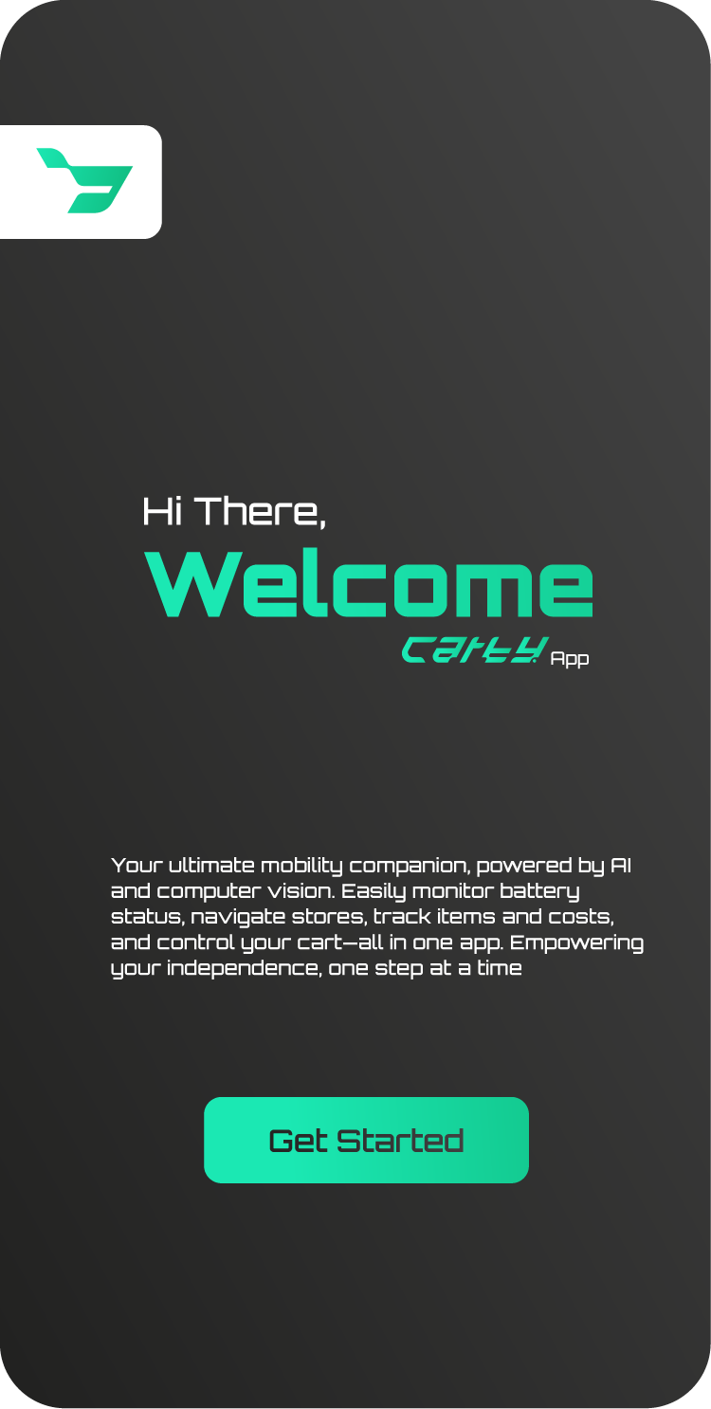
Figure 5.13 Application Interface
Figure 5.14 Welcome Page

5.10.2 Key Features of the App
- User Authentication:
  - The app welcomes users with a friendly introduction as shown in Figure 5.14 :"Hi there! Your ultimate mobility companion, powered by AI and computer vision."
  - Users can log in as shown in Figure 5.15 by providing their name, email, and phone number, ensuring a personalized experience.
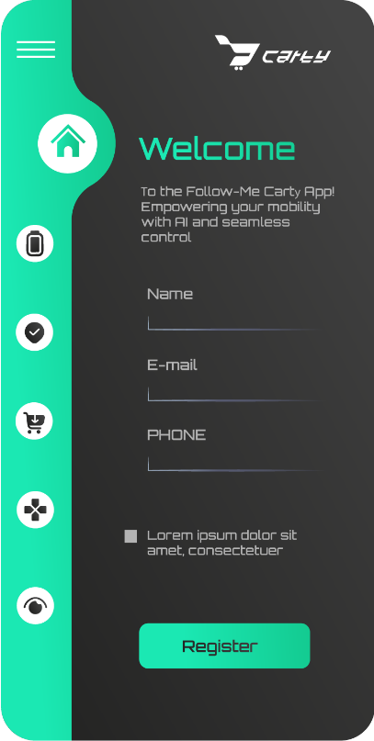
- Camera Integration:
Figure 5.15 Register and Log-in Page
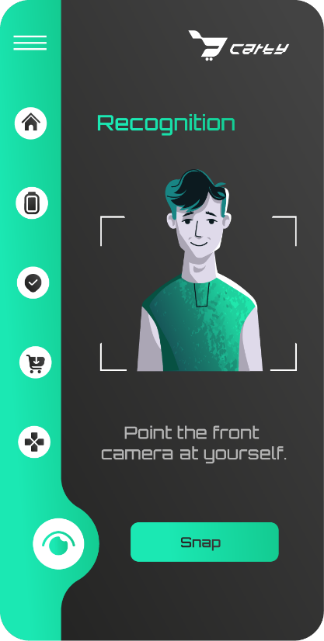
  - A feature prompts users to point the cart's front camera at themselves to initiate gesture or face recognition for seamless control, as shown in Figure 5.16.
Figure 5.16 Recognition Page
- Navigation and Section Tracking:
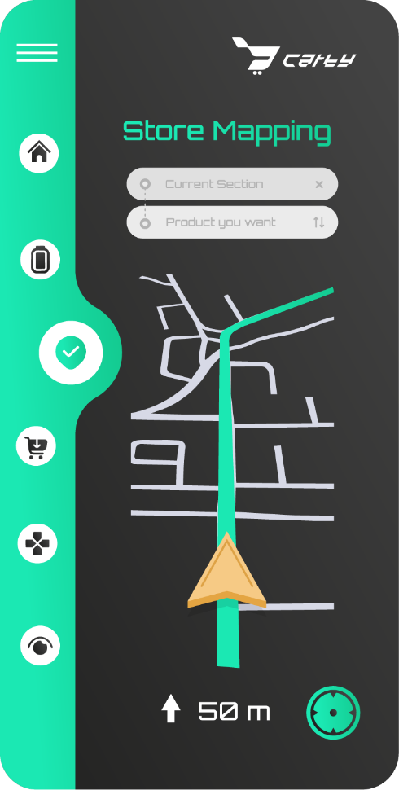
  - Users can navigate through store sections with a real-time indicator of their current location (e.g., "50 m, Current Section"), as shown in Figure 5.17.
Figure 5.17 Store Mapping Page
- Speed and Mode Control:
  - The app provides two control modes:
    - Automatic Mode: The cart follows the user autonomously.
    - Manual Mode: Users can control the cart’s movements directly through the app.
  - Speed levels (Low, Medium, High) can be adjusted as shown in Figure 5.18 based on user preference or environment.
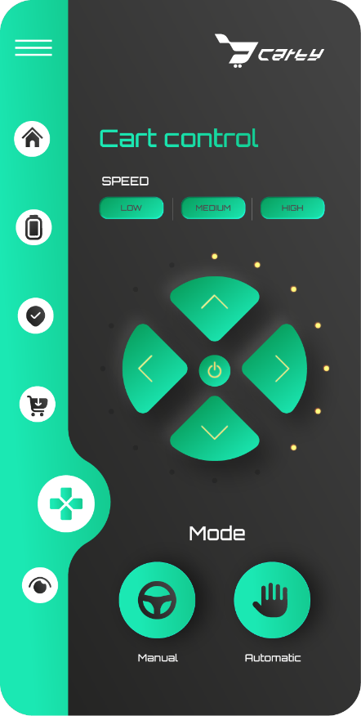
- Battery Monitoring:
Figure 5.18 Cart Control Page
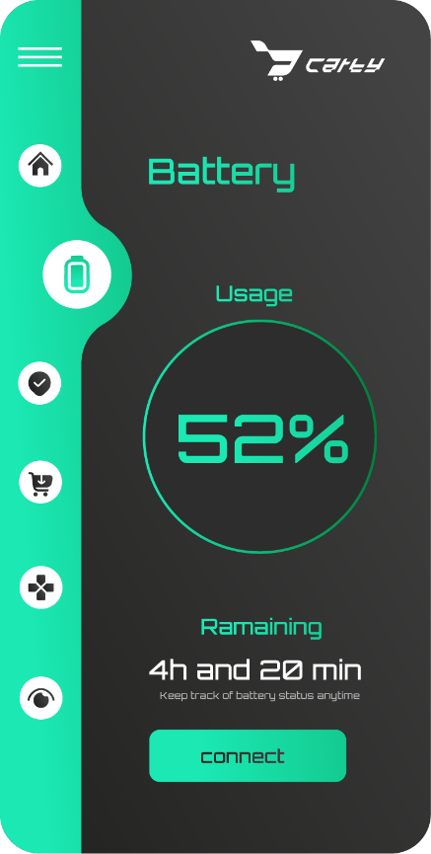
  - The battery status shown in Figure 5.19 is prominently displayed, including the remaining operational time.

Figure 5.19 Battery Monitoring Page
- Item and Cost Management:
  - The app provides real-time updates on the cart’s content as shown in Figure 5.20:
    - Number of Items: Displays how many items are currently in the cart.
    - Total Cost: Calculates and shows the cumulative cost of items.
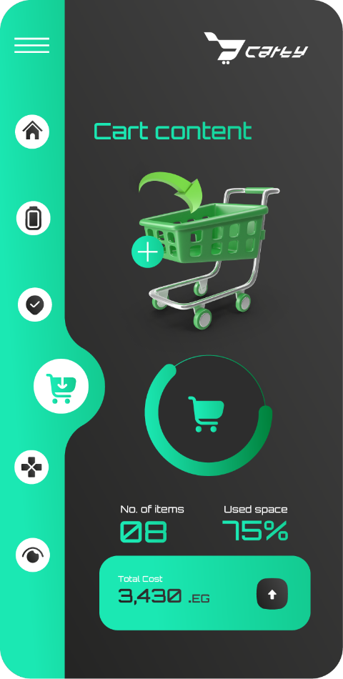
    - Storage Usage: Indicates the used and available storage space in the cart.
Figure 5.20 Cart Content Page
- Store Mapping:
  - The app includes a store mapping feature shown in Figure 5.17, allowing users to view a virtual map of the store layout.
  - Users can locate specific sections or products within the store, enhancing their shopping experience.

5.10.3 UI Design Principles
- Simplicity and Accessibility: The app is designed with a clean and minimalistic layout to ensure ease of use for elderly and disabled individuals.
- Real-Time Updates: All features, including battery status, navigation, and item tracking, provide live updates for enhanced usability.
- Intuitive Controls: Clear labels, large buttons, and straightforward navigation ensure that users can operate the app without confusion.
- Visual Feedback: The app provides visual cues, such as progress bars for battery life and storage usage, ensuring clarity.

5.10.4 Technical Implementation
- Frameworks and Tools: The app is developed using modern frameworks to ensure compatibility with Android and iOS devices.
- Integration with Cart Hardware:
  - The app communicates with the cart’s sensors, camera, and motors via a secure Bluetooth or Wi-Fi connection.
  - Data from the cart is processed in real-time to provide accurate feedback on battery life, location, and item tracking.
- AI and Computer Vision: AI algorithms enable gesture recognition and autonomous navigation, while computer vision processes input from the cart’s camera.

5.10.5 Conclusion
The "Follow-Me" cart app represents a significant step toward creating a seamless and intuitive user experience. By combining advanced technologies with user-centric design, the app empowers individuals with disabilities and elderly users to navigate their environments with independence and ease. Its integration with the cart’s hardware and software ensures a cohesive and efficient assistive mobility solution.

Chapter 6
Project Management
And Cost

6. Project Management and Cost

6.1 Project Management Procedure
Effective project management is essential to ensure the successful execution of the "Automated Follow-Me Cart Using AI and Computer Vision for Disabled and Elderly Assistance." This section details the steps and strategies employed during the project.

6.1.1 Idea Development
The project idea originated from recognizing the challenges faced by elderly and disabled individuals in carrying heavy loads or managing mobility aids. The team identified the potential of using AI and computer vision technologies to develop an automated cart that could follow users seamlessly. Brainstorming sessions involved exploring existing solutions, their limitations, and opportunities for improvement. The final concept was refined through feedback from academic supervisors and stakeholders, ensuring alignment with user needs and project objectives. Key goals included energy efficiency, user-friendliness, and advanced obstacle detection capabilities.

6.1.2 Resource Identification
Resource identification was a critical step that involved mapping out all necessary components and tools required for the project. The team divided resources into three categories:
- Mechanical Resources: Aluminum frames, wheels, axles, and structural components to build a robust and lightweight cart.
- Hardware Resources: High-performance processing units (e.g., Jetson Nano), sensors (e.g., ultrasonic and LiDAR), motor driver circuits, and power supply units.
- Software Resources: AI training platforms, computer vision libraries, and simulation tools for development and testing.
Vendor research was conducted to identify cost-effective yet reliable sources for these resources. Collaboration with suppliers ensured timely delivery, and negotiations helped minimize costs without compromising quality.

6.1.3 Timeline Estimation
To manage the project efficiently, a detailed timeline was created using project management software. The timeline was divided into six main phases:
- Research and Requirements Gathering: Conducting literature reviews, studying similar projects, and defining technical and functional requirements.
- Mechanical Design and Prototyping: Using SolidWorks to design the cart and performing stress analysis to ensure structural integrity.
- Hardware Integration and Testing: Procuring and assembling sensors, microcontrollers, and motor systems, followed by preliminary testing.
- Software Development and Debugging: Developing AI models for hand gesture recognition, integrating computer vision algorithms, and debugging the code.
- Final Assembly and System Integration: Combining mechanical, hardware, and software components into a cohesive system.
- Testing and Evaluation: Conducting extensive field tests to evaluate performance under real-world conditions and making necessary adjustments.
Regular progress reviews and milestone evaluations ensured that the project remained on schedule. Any deviations were promptly addressed through collaborative problem-solving.

- Timeline Schedule
Table 6.1 Timeline Schedule
Week | Task
Week 1 | Advanced search and collecting data
Week 2 | Sketching the design
Week 3 | Sensors and hardware parts selection
Week 4 | PCB designing
Week 5 | Tests for control codes applied
Week 6 | Designing on SOLIDWORKS
Week 7 | Fabricating for Mechanical Design and testing sensors
Week 8 | Gathering data for AI model and Applying computer vision
Week 9 | Coding in Jetson and Arduino
Week 10 | Combining the Jetson and the camera
Week 11 | Whole Project fabrication
Week 12 | Business plan and model
Week 13 | Trial and error tests
Week 14 | Presentation and report

6.1.4 Team Organization
The team of ten members was strategically divided into three specialized sub-teams to leverage individual strengths:
- Mechanical Team: Focused on designing and fabricating the cart’s structure, ensuring durability, stability, and efficiency.
- Hardware Team: Responsible for selecting and integrating sensors, microcontrollers, and actuators, as well as optimizing power management.
- Software Team: Tasked with developing AI models, implementing computer vision algorithms, and integrating hardware-software communication protocols.
Effective communication was maintained through weekly meetings, progress reports, and a shared project management platform. Team leaders from each sub-team coordinated with the project manager to ensure alignment of efforts.

6.1.5 Risk Management
A comprehensive risk management plan was developed to anticipate and mitigate potential challenges. Key risks and their mitigation strategies included:
- Hardware Failures: Regular testing and maintenance of components to prevent malfunctions.
- Software Bugs: Conducting iterative testing and debugging to ensure reliability.
- Integration Challenges: Allocating additional time and resources for system integration and testing.
- Budget Overruns: Maintaining a contingency fund to address unforeseen expenses.
The team’s proactive approach to risk management minimized disruptions and ensured smooth project execution.

6.2 Cost
The project’s cost analysis is divided into three main categories: mechanical, hardware, and software. Each category’s costs were meticulously tracked to ensure budget adherence. The detailed breakdown is provided below.

6.2.1 Mechanical Costs
Table 6.2 Mechanical Costs
Item | Description | Quantity | Unit Cost (EGP) | Total Cost (EGP)
Sheetmetal Frame | Lightweight structural frame | 4 | 375 | 1500
Wood Frame | Structural support frame made of wood | 3 | 75 | 225
Metal linking part | Metal connectors used to link various parts | 2 | 300 | 600
Wheels | High-durability wheels | 4 | 200 | 800
Motors |  | 4 | 1000 | 4000
  Electric motors for driving the cart
Couplers |  | 4 | 300 | 1200
  Connectors used to join motors to wheels
Fasteners and Nuts | Supporting components for assembly | 1 set | 100 | 100
Support Screws | Screws used for securing structural components | 3 | 100 | 300
Subtotal |  |  |  | 8,725

6.2.2 Hardware Costs
Table 6.3 Hardware Costs
Item | Description | Quantity | Unit Cost (EGP) | Total Cost (EGP)
Controller | High-performance processing unit | 1 | 5,000 | 5,000
Arduino Nano | Microcontroller for hardware control | 1 | 300 | 300
IR Sensors | Sensors for obstacle detection | 3 | 35 | 105
Joystick | Input device for manual control of the cart | 1 | 40 | 40
Camera | Vision system for obstacle detection | 1 | 1500 | 1500
Motor Driver Circuit | Controllers for motor operations | 2 | 250 | 500
Battery | Supplies power to the system | 1 | 650 | 650
Extra PCBs (Safety and Nano Control) | Additional printed circuit boards for safety and control systems | 2 | 150 | 300
Others | Miscellaneous components for the system |  |  | 450
Subtotal |  |  |  | 8,845

6.2.3 Software Costs
Table 6.4 Software Costs
Item | Description | Cost Type | Cost (USD)
Testing Tools | Software licenses for simulations | Subscription | 400
Subtotal |  |  | 400

6.2.4 Total Cost
The total cost of the project is summarized as follows:
Table 6.5 Total Cost
Category | Total Cost (EGP)
Mechanical | 8,725
Hardware | 8,845
Software | 400
Grand Total | 17,970

Through meticulous planning, resource allocation, and cost management, the team ensured that the project met its objectives within the allocated budget. These efforts were instrumental in achieving a functional and reliable solution for elderly and disabled assistance.

Chapter 7
Development
and Recommendations

7. Development and Recommendations

7.1 Introduction
The development process for the "Automated Follow-Me Cart Using AI and Computer Vision for Disabled and Elderly Assistance" presented unique challenges and opportunities across mechanical, hardware, and software domains. This chapter provides an in-depth discussion of the problems encountered, the solutions implemented, and future recommendations to enhance the system’s performance and usability.

7.2 Problems and Solutions

7.2.1 Mechanical Problems
- Problem: Achieving a lightweight yet robust design to support heavy loads while remaining portable.
  - Solution: The mechanical team employed iterative simulations in SolidWorks to refine the structural design. Aluminum was chosen as the primary material due to its favorable strength-to-weight ratio. The design was stress-tested to ensure it could handle dynamic forces during operation.
- Problem: Misalignment of the wheels and axles caused inefficient movement and excessive wear.
  - Solution: Precision machining techniques were used to ensure proper alignment. Adjustable mounting brackets and high-grade bearings were selected to reduce friction and accommodate minor alignment adjustments.
- Problem: Difficulty in integrating the drive mechanism with the cart’s structural frame.
  - Solution: Custom brackets were designed to securely mount motors and axles. Flexible couplings were used to minimize vibration and improve power transmission.
- Problem: Challenges with terrain adaptability.
  - Solution: The cart’s wheels were upgraded to larger, all-terrain types, and shock-absorbing mounts were added to improve performance on uneven surfaces.

7.2.2 Hardware Problems
- Problem: Sensor inaccuracies, particularly with ultrasonic sensors in crowded environments.
  - Solution: A combination of sensor fusion techniques was used. Ultrasonic sensors were complemented with LiDAR for precise distance measurements and object detection. A filtering algorithm was implemented to reduce noise in sensor data.
- Problem: Limited power efficiency leading to reduced operational time.
  - Solution: A high-capacity, rechargeable lithium-ion battery pack was integrated. The team optimized power consumption by adjusting the duty cycle of the motors and other hardware components during operation.
- Problem: Overheating of electronic components during prolonged use.
  - Solution: Heat sinks and cooling fans were installed on key components, such as the Jetson Nano and motor drivers, to dissipate heat effectively. Thermal paste was applied to ensure optimal heat transfer.
- Problem: Signal interference between components, particularly in high-current pathways.
  - Solution: Shielded cables were used for signal transmission, and sensitive components were grounded properly to reduce electromagnetic interference.

7.2.3 Software Problems
- Problem: Low initial accuracy in hand gesture recognition due to insufficient training data.
  - Solution: The team expanded the dataset by collecting diverse gesture samples under different lighting and environmental conditions. Data augmentation techniques, such as flipping, rotation, and scaling, were applied to create a robust training set.
- Problem: Lag in real-time processing of obstacle detection and gesture commands.
  - Solution: The software team optimized the AI models by reducing their complexity and leveraging hardware acceleration provided by the Jetson Nano’s GPU. Multithreading techniques were used to handle multiple tasks simultaneously.
- Problem: Difficulty in synchronizing hardware and software operations during system integration.
  - Solution: A modular programming approach was adopted, with clearly defined APIs for communication between hardware and software components. This allowed independent testing and debugging before full integration.
- Problem: Limited user interface for debugging and monitoring.
  - Solution: A simple graphical interface was developed to display real-time sensor data, system status, and error messages, aiding in debugging and system monitoring.

7.3 Future Work

7.3.1 Mechanical Enhancements
- Develop a modular frame design to enable easy disassembly and portability, making the cart suitable for transportation and storage.
- Explore the use of advanced composite materials, such as carbon fiber, to achieve further weight reduction while maintaining structural strength.
- Integrate a suspension system for improved performance on uneven and rugged terrains, enhancing user comfort and cart stability.
- Investigate the feasibility of adding load sensors to monitor weight distribution and adjust motor power accordingly.

7.3.2 Hardware Upgrades
- Incorporate additional sensors, such as stereo cameras or depth cameras, to provide a richer perception of the environment and improve obstacle avoidance capabilities.
- Upgrade the motor system to include brushless DC motors for higher efficiency, durability, and quieter operation.
- Implement a wireless charging system for convenient battery recharging without manual intervention.
- Enhance the connectivity options by adding Bluetooth and Wi-Fi modules, enabling seamless integration with other devices and platforms.

7.3.3 Software Improvements
- Enhance AI models by incorporating transfer learning techniques to further improve accuracy in gesture recognition.
- Develop a smartphone application that allows users to remotely control the cart, customize settings, and monitor performance metrics.
- Add voice command functionality to provide an alternative control method, particularly beneficial for users with limited hand mobility.
- Implement predictive algorithms to anticipate user behavior and optimize the cart’s movement patterns.
- Introduce a self-diagnostic system that alerts users to potential issues, such as low battery or sensor malfunctions, before they impact performance.

7.4 Recommendations
Table 7.1 Recommendations
Aspect | Details
Maintenance | Regular cleaning and lubrication of mechanical components to ensure smooth operation and longevity.
Sensor Calibration | Periodic calibration of sensors to maintain accuracy and reliability in obstacle detection and gesture recognition.
User Testing | Continuous user testing and feedback collection to guide future iterations and address evolving needs.
Scalability | Collaboration with industry professionals to optimize the design for mass production, ensuring scalability and cost-effectiveness.
Documentation | Maintaining detailed records of components and processes for troubleshooting, upgrades, and knowledge transfer.

By addressing the challenges encountered during development and implementing the proposed future improvements, this project can achieve its full potential as an innovative mobility aid, significantly enhancing the quality of life for elderly and disabled individuals.

References
- World Health Organization (WHO), 2020 - Discusses global disability statistics and mobility challenges.
https://www.who.int/news-room/fact-sheets/detail/disability-and-health
- Akgün, Ö., & Öztürk, S., 2018 - Focused on autonomous navigation systems for electric wheelchairs.
https://ieeexplore.ieee.org/document/8452435
- Brooks, R., 1986 - Addressed challenges in enabling autonomous mobile robots to navigate dynamic environments.
- Bhattacharya, A., et al., 2017 - Explored autonomous service robots and sensor fusion for navigation.
https://ieeexplore.ieee.org/document/7983666
- Hossain, M., et al., 2020 - Studied deep learning for hand gesture recognition to control robotic arms.
https://ieeexplore.ieee.org/document/8674634
- Sadeghi, F., et al., 2019 - Investigated the use of convolutional neural networks for real-time robotic control via hand gestures.
https://arxiv.org/abs/2202.12519
- Yang, X., et al., 2018 - Highlighted sensor fusion for environmental mapping and obstacle avoidance.
https://ieeexplore.ieee.org/document/6935628
- Kamal, A., et al., 2019 - Developed dynamic path planning algorithms for environments with changing obstacles.
https://ieeexplore.ieee.org/document/9367336
- Sharma, R., et al., 2020 - Demonstrated the effectiveness of convolutional neural networks in gesture recognition under constrained resources.
https://ieeexplore.ieee.org/document/9837407
- Ultralytics GitHub Repository - Official repository for YOLOv8 by Ultralytics.
- Mediapipe by Google AI - An open-source framework for building multimodal machine learning pipelines.
https://ai.google.dev/
- Numpy - The fundamental package for numerical computation in Python.
https://numpy.org/
- PyTorch - A deep learning framework for research and production.
https://pytorch.org/
- Janet Finlay & Alan Dix, An Introduction to Artificial Intelligence - Comprehensive book on AI concepts and applications.
- Microchip Technology Inc. - Manufacturer and documentation provider for embedded control solutions.
https://www.microchip.com/
- Mr. Mohamed Abdelbaset’s Notes - Unpublished personal notes related to project implementation and design.

